CCCS LOR User Guide

Single Item Submission
Welcome to the CCCS LOR. This document was created to assist with the single item submission process within your Community. This document will cover adding submissions, editing completed submissions and deleting completed submissions.
NOTE: To complete any tasks in the CCCS LOR, make sure you are already logged into http://lor.cccs.edu using the credentials provided to you.

ADDING (SUBMITTING) MATERIALS

- Type http://lor.cccs.edu into your browser address bar, and login.
- Click “Contribute Materials” located in the middle of the CCCS LOR homepage.
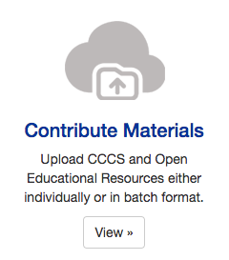

- Select the appropriate Collection from the dropdown menu and click “Next” to start your submission.
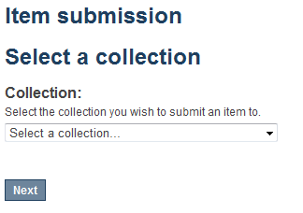
- Entering your Item Description
The single item submission process is a six step process that allows you to enter all the metadata about your material, upload the associated files, review your submission, and finally submit the item to the repository. Enter as much information about the item as you can in order to help others find it in the repository. Each field has a brief description of the data you should enter into the field. The following pages provide some additional information about each field.
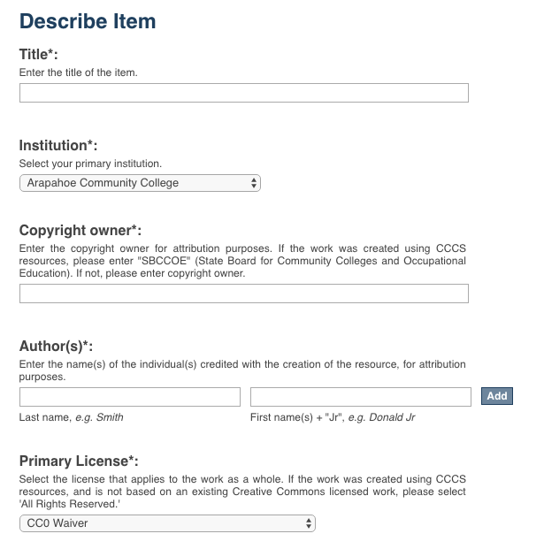
Primary License: (REQUIRED FIELD) Select the license that applies to the majority of items in the work. Most resources will be CC BY (the default choice) according to the grant requirements.
Title (REQUIRED FIELD): Enter the title of your item.
Institution (REQUIRED FIELD): Select the name of your primary institution.
Copyright owner (REQUIRED FIELD): Enter the copyright owner for attribution purposes. If the work was created using CCCS resources, enter “SBCCOE”. If not, enter copyright owner.
Author(s) (REQUIRED FIELD): Enter the first and last name of the author. To add multiple authors click the “Add” button.
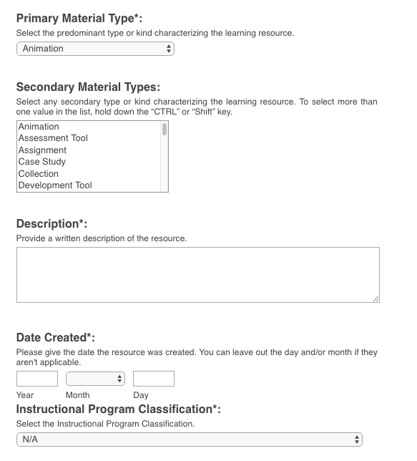
Primary Material Type: (REQUIRED FIELD) Select the predominant type or kind of material characterizing the learning resource you are uploading.

Secondary Material Types: Select any secondary type or kind characterizing the learning resource you are uploading. To select more than one value in the list, hold down the “CTRL” or “Shift” key.
Description: (REQUIRED FIELD) Use this field to describe the material in as much detail as possible so others can find it when searching the repository. A detailed description also helps users decide if it is an appropriate material for their use. Be as specific as possible so others can understand what the material is about.
Date Created: (REQUIRED FIELD) The “Year” field is required.
Instructional Program Classification: (REQUIRED FIELD) Select the relevant CIP code to classify the instructional program that the item or course originally belonged to.
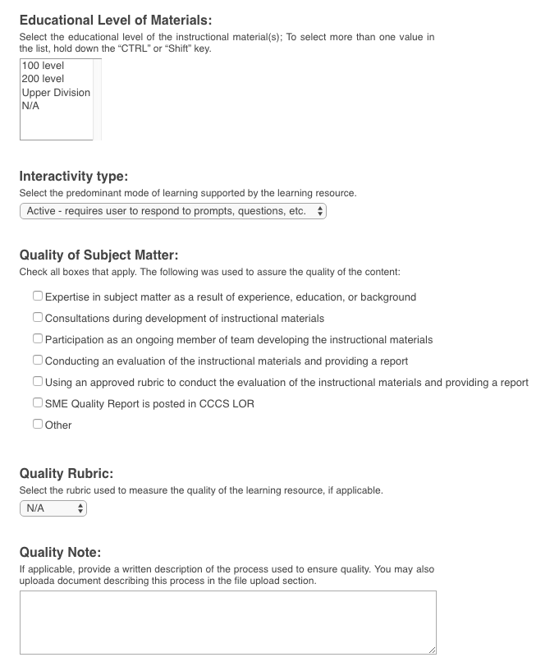
Quality Note: Written description of the process used to ensure quality. You may also upload a document describing this process in the file upload section near the end of the submission process. See the Tutorials & User Guides page in skillscommons.org for a QOLT rubric that can be filled out and uploaded at the end of the submission process.

Quality Rubric: Select the rubric used to measure the quality of the learning resource.
Quality of Subject Matter: (REQUIRED FIELD) Check all boxes that apply.
Interactivity type: (REQUIRED FIELD) Select the predominant mode of learning supported by the learning resource.
Educational Level of Material: (REQUIRED FIELD) Select the educational level of the instructional material(s); To select more than one value in the list, hold down the “CTRL” or “Shift” key.
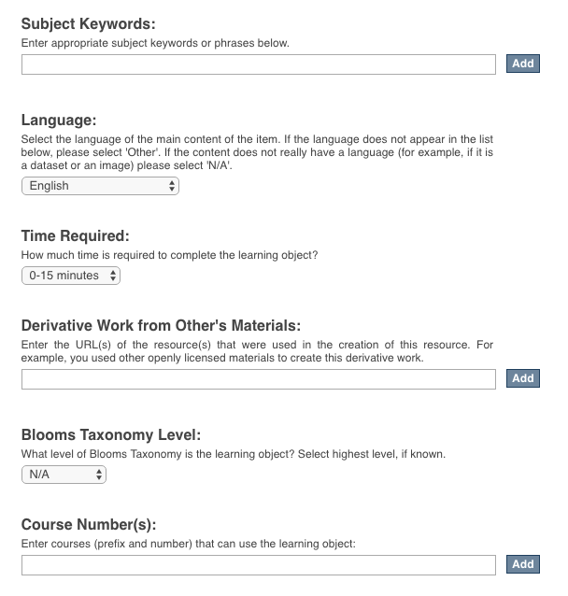
Subject Keywords: Keywords allow users to find materials in the repository. Enter multiple keywords by clicking the “Add” button after each keyword.
Time Required: Provide the approximate or typical time it takes to work with or through this learning resource for the typical intended target audience.
Language: Select the language of the main content of the item.
Derivative Work from Other’s Materials: Enter the URL(s) of the resource(s) that were used in the creation of this resource. For example, you used other openly licensed materials to create this derivative work. Click the “Add” button to add more than one URL.
Blooms Taxonomy Level: Select the highest level of Blooms Taxonomy for the learning object, if known.

Course Number(s): Enter the courses (prefix and number) that can use the learning object

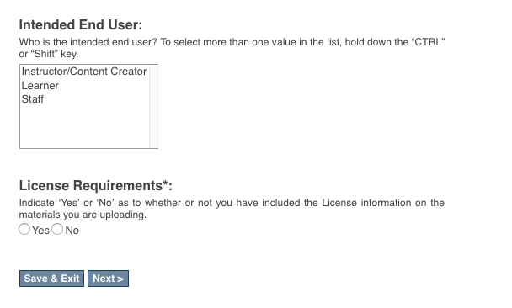
License Requirements: Select “Yes” or “No” as to whether you have included the License Information on the materials you are uploading.
Intended End User: Select the intended end user(s) for your learning object. To select more than one, hold down the “CTRL” or “Shift” key.
- Clicking “Next” will take you to the uploading files page.
- Uploading your files – NOTE: Before uploading your files make sure that the CC-BY license and DOL disclaimer is on all materials you upload to the repository.
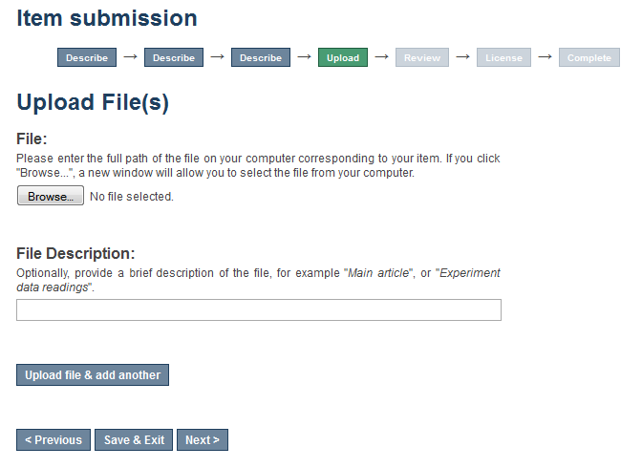
Browse for and select the file you would like to upload.
If you would like to upload multiple files click “Upload file & add another”
Reminder – don’t forget to upload your Quality Assurance Report and your Accessibility Checkpoint Form if applicable.
Provide a brief description of the file. The description you provide should be helpful to someone considering whether to download the material. As an example, "Workshop Announcement Flyer" is more helpful than "Workshop Document."
Click “Previous” to go back a page. Click “Save & Exit” if you would like to come back later and finish. Click “Next” to continue entering data.

- If you are uploading multiple files and you click on “Upload file & add another” you will be presented with the following screen. Here you will be able to “Browse” for and upload additional files, edit a previously uploaded file, as well as remove a previously uploaded file.
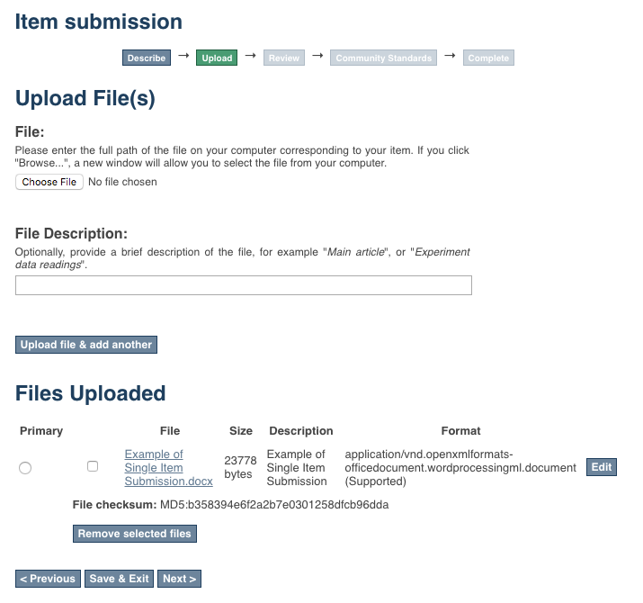
Click “Edit” to edit an existing uploaded file
To remove a previously uploaded file click the check box located to the left of the file name and then click “Remove selected file”
If you have multiple files you can use the radio button to indicate which of the files is the primary file for this submission.
Click “Upload file & add another”
Add a brief description of the file.
Click “Choose File” to upload another file.
- After you click “Next” you will have a chance to review your work and make changes on the Review Submission page.
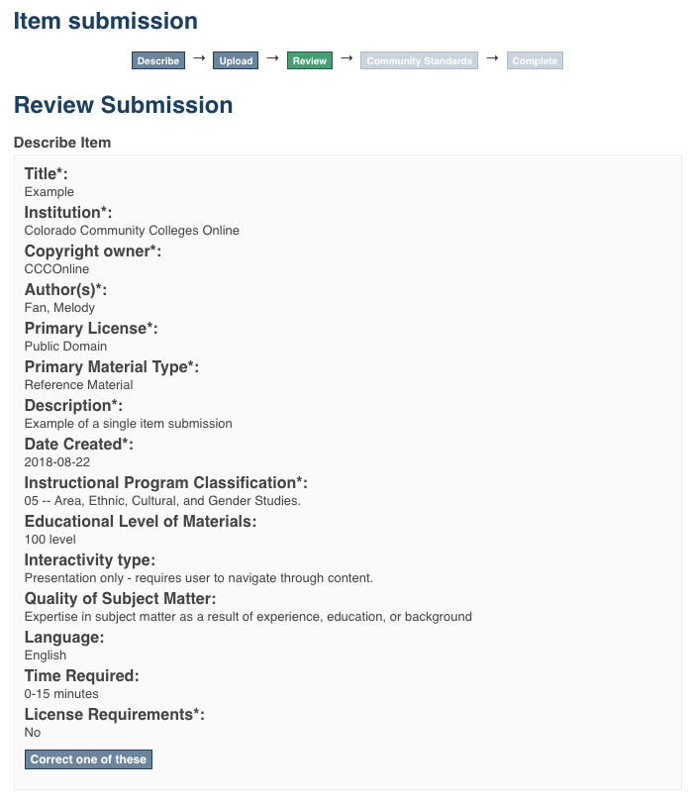
To make a correction, click the “Correct one of these” buttons located at the end of each section.
- Once you are satisfied with your submission, click on the “Complete Submission” button at the bottom of the page.
- Your submission is complete. You will receive an e-mail notification when your submission has been added to the collection.
Submit another item.
View your recently submitted items.

EDITING AN ITEM IN THE REPOSITORY

- Type http://lor.cccs.edu into your browser address bar, and login.
- Click “Contribute Materials” located in the middle of the CCCS LOR homepage.
- Once you have signed in click on the submission you wish to edit. For our purposes we will edit the “Example” item.
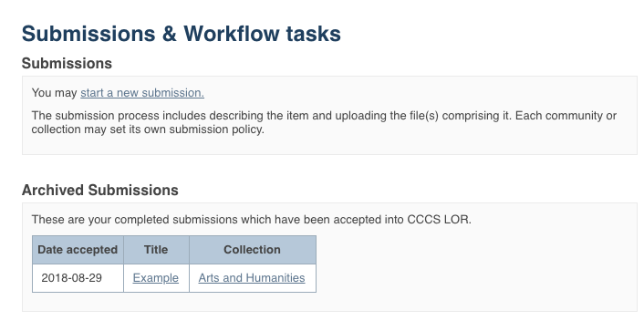
PLEASE NOTE: if there is an item you wish to edit but you are not the original creator of the item it will not show up in your Archived Submissions. To access this item for editing find the item in the repository and then follow the instructions beginning at step number 5 below.
- You are now on the item page. To edit this item click on “Edit this item” under the “Context” heading.
Click on “Edit this item” under the “Context” heading
- After clicking on “Edit this item” you will be presented with the screen below. Click on the “Item Metadata” tab to edit the fields in this item.
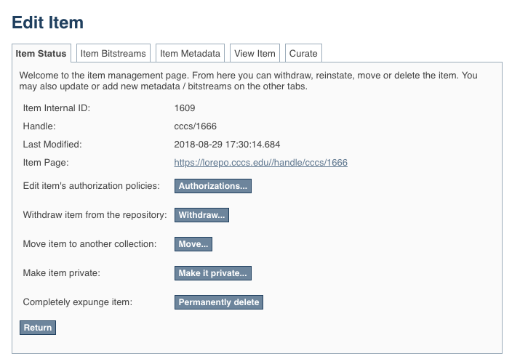
Click on “Item Metadata” to edit the fields in this item.

- After clicking “Item Metadata” you will be presented with the full Metadata record. This record will show you the fields that you initially entered when you first submitted the item.
TO ADD A NEW FIELD - find the field metadata name in the “Name” dropdown menu. Please see the Metadata and Appendices page for full list of fields and associated metadata names.
PLEASE NOTE: These changes are not validated in any way. You are responsible for entering the data in the correct format. If you are not sure what the format is, please do NOT make changes. If you need assistance making edits please contact our support staff at http://lor.cccs.edu/contact/.
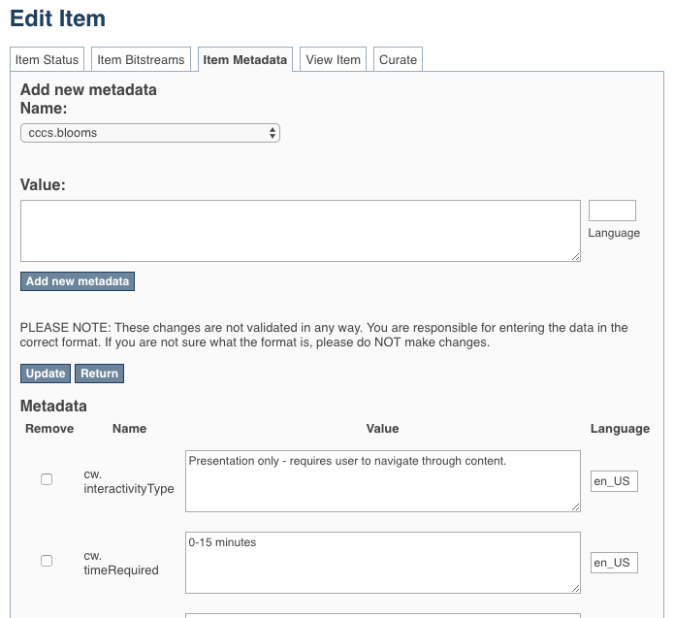
To update a field that you already entered, scroll down and find the field you wish to update and type the new information.
Be sure to click on the “Update” button found at the top or bottom of the page.

To add a field that you missed or skipped when you first submitted your item, find it in the “Name” dropdown menu.
See the Metadata and Appendices page for full list of fields and associated metadata names.
In our example we are going to add a URL to the “URL to Formal Accessibility Policy” field.
Click “Add new metadata” and your field will be added.
Add the information to the “Value” field.
In our example we are going to add a link to the California State University Formal Accessibility Policy.

TO ADD ANOTHER VALUE TO A REPEATABLE FIELD
See the Metadata and Appendices page to see which fields are repeatable. The field “Author(s)” is a repeatable field. For this next example we will add another author to our item.
Please see the Metadata and Appendices page and make sure that the field you are about to add is a repeatable. If it is not repeatable please do not add another field.
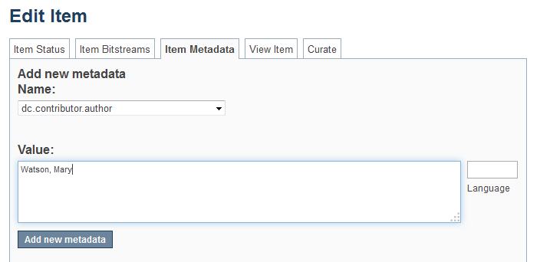
To add another entry to a repeatable field, find it in the “Name” dropdown menu.
See the Metadata and Appendices page for full list of fields and associated metadata names.
In our example we are going to add another author to the “Author(s)” field which corresponds to the “dc.contributor.author” metadata name.
Add the information to the “Value” field.
You must type the value in the appropriate format. If you are unsure of the format check the Metadata and Appendices page at the end of this document.
In this case, the format is [Last Name, First Name].
Click “Add new metadata”
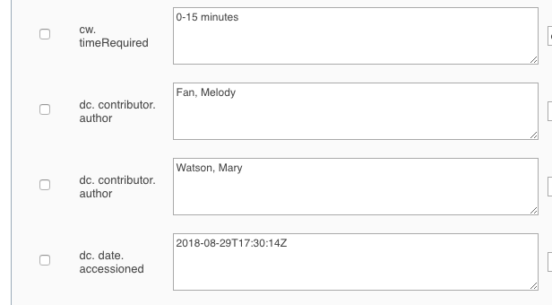
After you clicked “Add new metadata” scroll down to see that you now have another author assigned to the “dc.contributor.author” field.

TO ADD/UPLOAD MORE FILE(S) – Click on the “Item Bitstream” tab. You will be presented with a list of the file(s) that you initially uploaded.
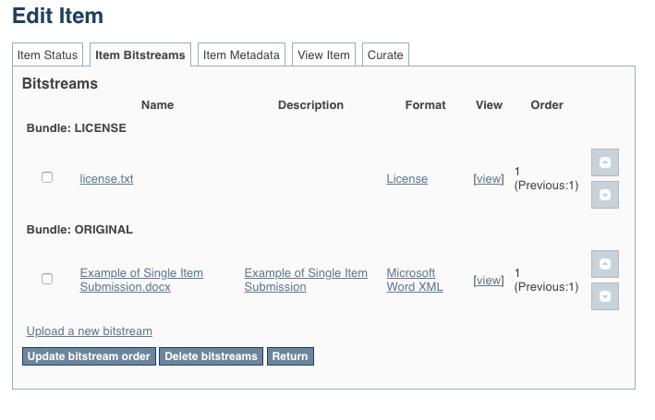
Click on the “Item Bitstreams” tab.
NOTE: The “license.txt” is added when you agree to the terms of service. Please do not edit or delete this item.
This “txt” file does not contain any metadata about your chosen CC BY license.

To upload a new file click on “Upload a new bitstream” link and follow directions to upload your new file(s).

TO DELETE UPLOADED FILE(S) – Click on the “Item Bitstream” tab. You will be presented with a list of the file(s) that you initially uploaded.
Click “Delete bitstreams”
Select the file(s) you want to delete using the check box.
Click on the “Item Bitstream” tab.
NOTE: The “license.txt” is added when you agree to the terms of service. Please do not edit or delete this item.
This “txt” file does not contain any metadata about your chosen CC BY license.

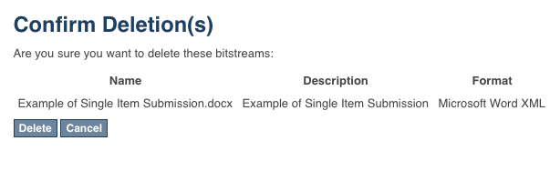
Confirm the deletion(s) by clicking “Delete”
TO EDIT UPLOADED FILE(S) – Click on the “Item Bitstream” tab. You will be presented with your list of uploaded file(s).
Click on the “Item Bitstream” tab.
NOTE: The “license.txt” is added when you agree to the terms of service. Please do not edit or delete this item.
This “txt” file does not contain any metadata about your chosen CC BY license.
Click on the name of the item you would like to edit. Make your edits and click “Save”

DELETING AN ITEM IN THE REPOSITORY

- Type http://lor.cccs.edu into your browser address bar, and login.
- Click “Contribute Materials” located in the navigation menu in the middle of the CCCS LOR homepage.
- Once you have signed in you will see your previous submissions in the “Archived Submissions” area. Click on the submission you wish to delete. For our purposes we will delete the “Example” item.
PLEASE NOTE: if there is an item you wish to delete but you are not the original creator of the item it will not show up in your Archived Submissions. To access this item please find the item in the repository and then follow the instructions beginning at step number 5 below.

- You are now on the item page. To delete this item click on “Edit this item” under the “Context” heading.
Click on “Edit this item” under the “Context” heading.

- After clicking on “Edit this item” you will be presented with the screen below. To delete this item click the “Permanently delete” button.
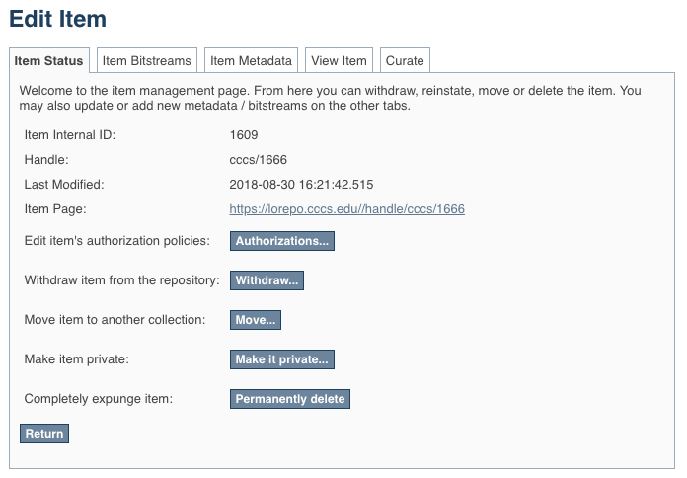
Click “Permanently delete” to remove this item from the repository.
- After clicking “Permanently delete” you will be presented with the full item record. Scroll to the bottom of the page and click “Delete” to permanently delete the item.
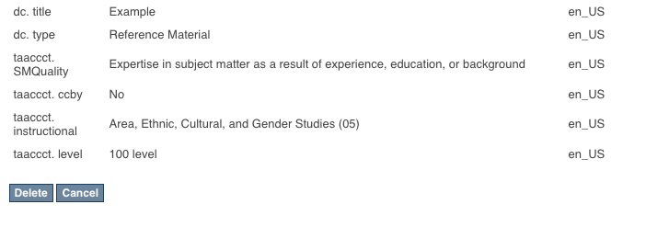
Click “Delete” to permanently delete the item. If you do not want to delete it at this time, click “Cancel”

Metadata and Appendices
http://lor.cccs.edu/support-center/contribute-manage/metadata-and-appendices/

This work is licensed under a Creative Commons Attribution 4.0 International License.
This workforce solution was created through a cooperative agreement between the U.S. Department of Labor's Employment and Training Administration and the California State University-Multimedia Educational Resource for Learning and Online Teaching (MERLOT).

