CCCS LOR User Guide

Editing an Item in the Repository
NOTE: To complete any tasks in the CCCS LOR, make sure you are already logged into http://lor.cccs.edu using the credentials provided to you.

EDITING AN ITEM IN THE REPOSITORY

- Type http://lor.cccs.edu into your browser address bar, and login.
- Click “Contribute Materials” located in the middle of the CCCS LOR homepage.
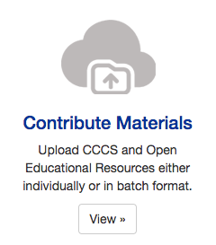
- Once you have signed in click on the submission you wish to edit. For our purposes we will edit the “Example” item.
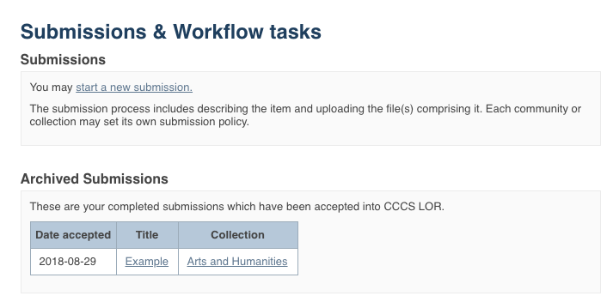
PLEASE NOTE: if there is an item you wish to edit but you are not the original creator of the item it will not show up in your Archived Submissions. To access this item for editing find the item in the repository and then follow the instructions beginning at step number 5 below.

- You are now on the item page. To edit this item click on “Edit this item” under the “Context” heading.
Click on “Edit this item” under the “Context” heading

- After clicking on “Edit this item” you will be presented with the screen below. Click on the “Item Metadata” tab to edit the fields in this item.
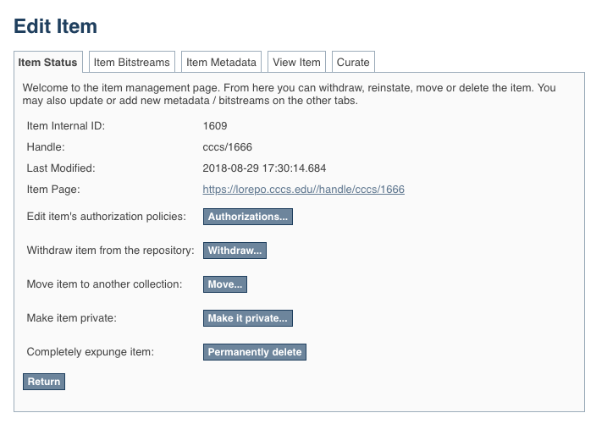
Click on “Item Metadata” to edit the fields in this item.

- After clicking “Item Metadata” you will be presented with the full Metadata record. This record will show you the fields that you initially entered when you first submitted the item.
TO ADD A NEW FIELD - find the field metadata name in the “Name” dropdown menu. Please see the Metadata and Appendices page for full list of fields and associated metadata names.
PLEASE NOTE: These changes are not validated in any way. You are responsible for entering the data in the correct format. If you are not sure what the format is, please do NOT make changes. If you need assistance making edits please contact our support staff at http://lor.cccs.edu/contact/.
To add a field that you missed or skipped when you first submitted your item, find it in the “Name” dropdown menu.
See the Metadata and Appendices page for full list of fields and associated metadata names.
In our example we are going to add a URL to the “URL to Formal Accessibility Policy” field.
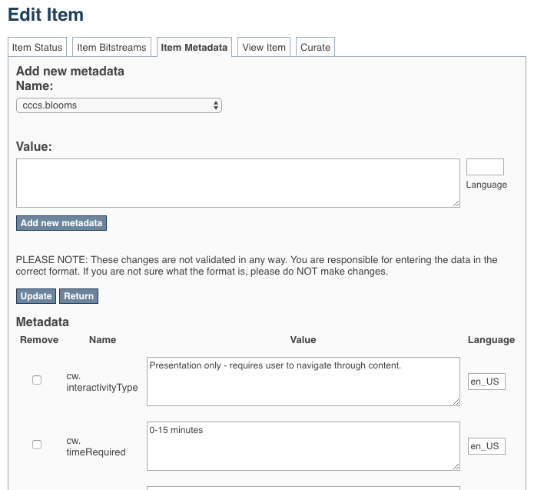
To update a field that you already entered, scroll down and find the field you wish to update and type the new information.
Be sure to click on the “Update” button found at the top or bottom of the page.

Click “Add new metadata” and your field will be added.
Add the information to the “Value” field.
In our example we are going to add a link to the California State University Formal Accessibility Policy.
TO ADD ANOTHER VALUE TO A REPEATABLE FIELD
See the Metadata and Appendices page to see which fields are repeatable. The field “Author(s)” is a repeatable field. For this next example we will add another author to our item.
Please see the Metadata and Appendices page and make sure that the field you are about to add is a repeatable. If it is not repeatable please do not add another field.
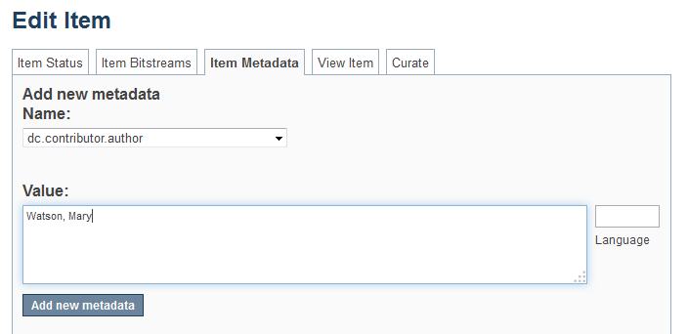
Click “Add new metadata”
To add another entry to a repeatable field, find it in the “Name” dropdown menu.
See the Metadata and Appendices page for full list of fields and associated metadata names.
In our example we are going to add another author to the “Author(s)” field which corresponds to the “dc.contributor.author” metadata name.
Add the information to the “Value” field.
You must type the value in the appropriate format. If you are unsure of the format check the Metadata and Appendices page at the end of this document.
In this case, the format is [Last Name, First Name].
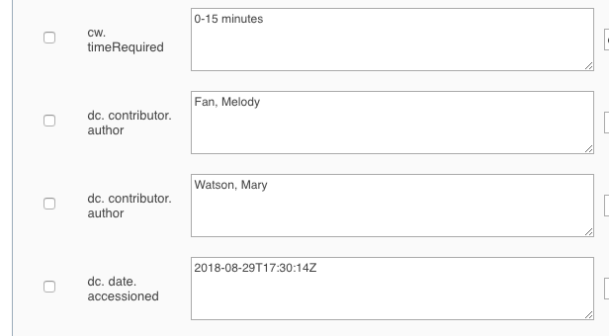
After you clicked “Add new metadata” scroll down to see that you now have another author assigned to the “dc.contributor.author” field.

TO ADD/UPLOAD MORE FILE(S) – Click on the “Item Bitstream” tab. You will be presented with a list of the file(s) that you initially uploaded.
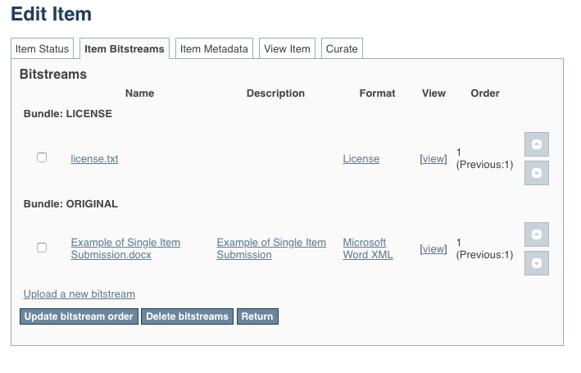
Click on the “Item Bitstreams” tab.
NOTE: The “license.txt” is added when you agree to the terms of service. Please do not edit or delete this item.
This “txt” file does not contain any metadata about your chosen CC BY license.

To upload a new file click on “Upload a new bitstream” link and follow directions to upload your new file(s).

TO DELETE UPLOADED FILE(S) – Click on the “Item Bitstream” tab. You will be presented with a list of the file(s) that you initially uploaded.
Click “Delete bitstreams”
Select the file(s) you want to delete using the check box.
Click on the “Item Bitstream” tab.
NOTE: The “license.txt” is added when you agree to the terms of service. Please do not edit or delete this item.
This “txt” file does not contain any metadata about your chosen CC BY license.

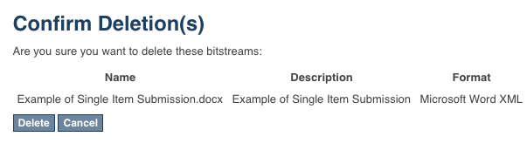
Confirm the deletion(s) by clicking “Delete”
TO EDIT UPLOADED FILE(S) – Click on the “Item Bitstream” tab. You will be presented with your list of uploaded file(s).
Click on the “Item Bitstream” tab.
NOTE: The “license.txt” is added when you agree to the terms of service. Please do not edit or delete this item.
This “txt” file does not contain any metadata about your chosen CC BY license.
Click on the name of the item you would like to edit. Make your edits and click “Save”

Metadata and Appendices
http://lor.cccs.edu/support-center/contribute-manage/metadata-and-appendices/

This work is licensed under a Creative Commons Attribution 4.0 International License.
This workforce solution was created through a cooperative agreement between the U.S. Department of Labor's Employment and Training Administration and the California State University-Multimedia Educational Resource for Learning and Online Teaching (MERLOT).

