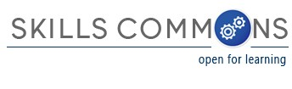

TAACCCT Grant Projects in Healthcare Industry contributing materials
to SkillsCommons.org Repository in various industry sectors.
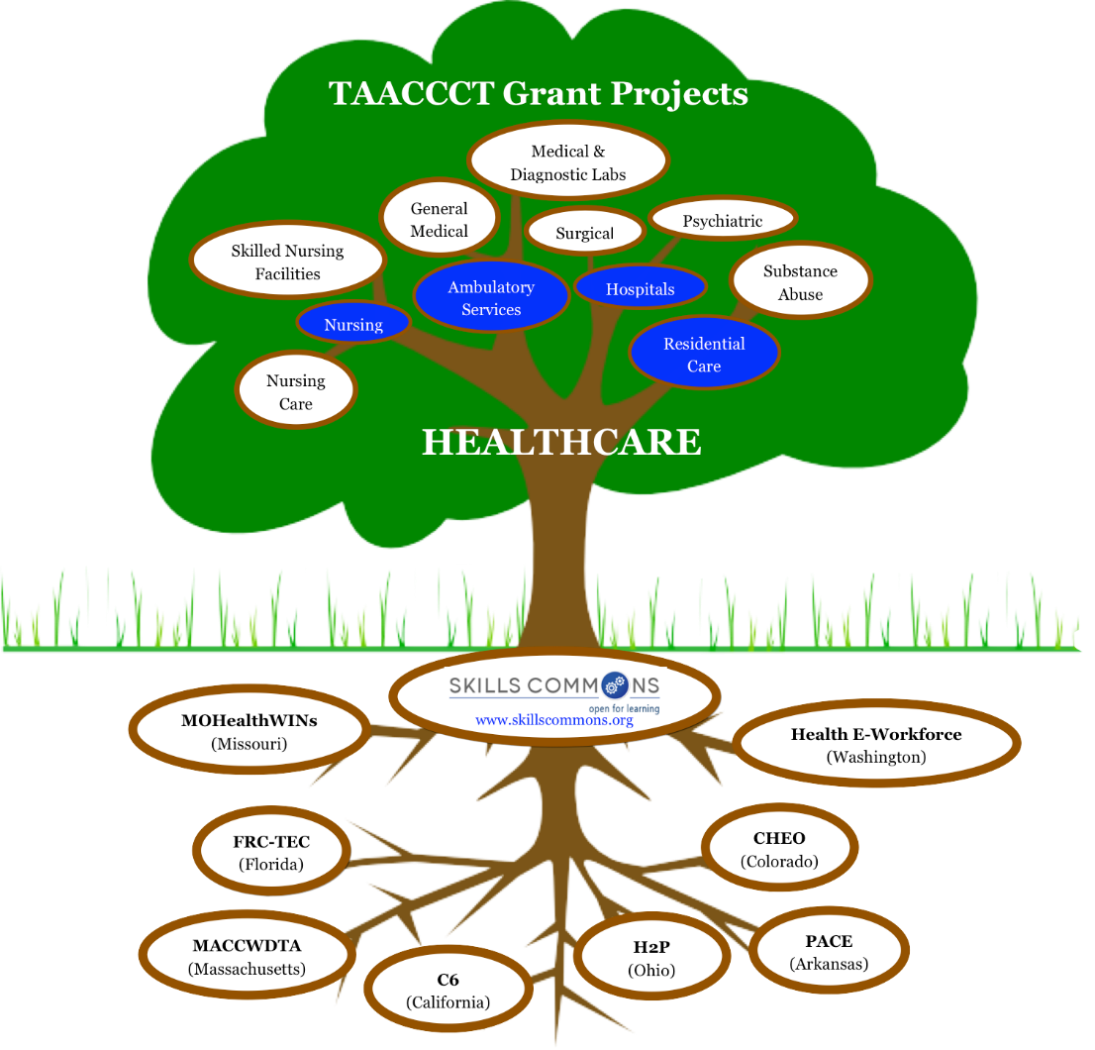
Browse the SkillsCommons.org Repository for Materials by Industry & Sectors
- Instructional Materials: Hybrid/Blended Courses, Online Courses, Presentations, Animations, etc.
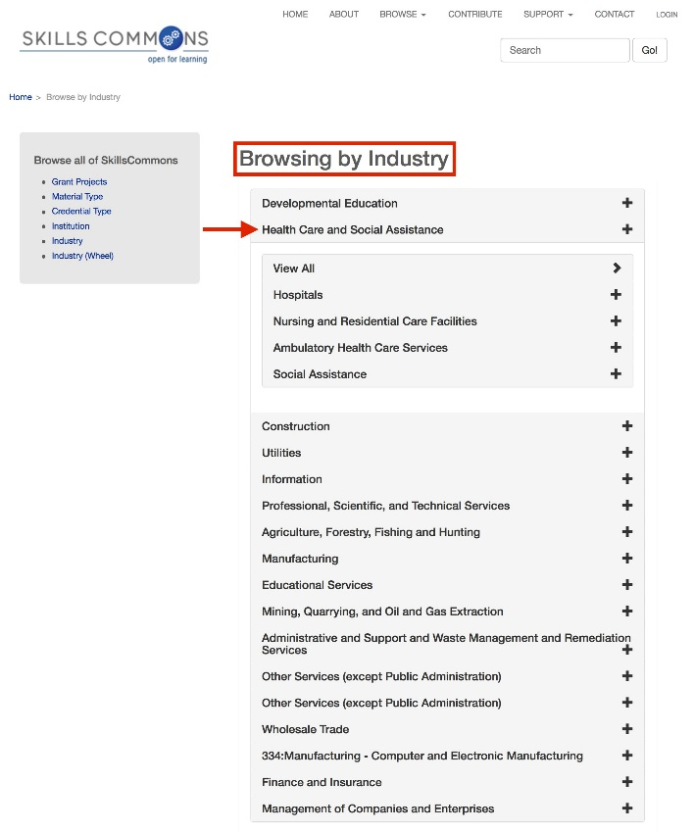
- Program Support Materials: Recruitment & Outreach, Grant Management, Articulations & Agreements, etc.

The SkillsCommons.org Support Services Center
  - Guidelines and Strategies for Preparing & Uploading Content
  - Use Case for a Campus Program Manager (Re)Using Materials in SkillsCommons
  - Creative Commons licensing Guidelines
  - Accessibility Guidelines
  - Strategies for Assuring the Quality of Online and Hybrid Courses,
  - Open Educational Resources – Finding More OER with MERLOT

This work is licensed under a Creative Commons Attribution 4.0 International License.

- FAQs

This workforce solution was created through a cooperative agreement between the U.S. Department of Labor's Employment and Training Administration and the California State University-Multimedia Educational Resources for Learning and Online Teaching (MERLOT).
support@skillscommons.org

