Forms of Reuse and Derivative Works
- With a complete unit of material

  - Teaching with contributed materials, unmodified.
    - Instructor Jones is now teaching Instructor Smith’s material as a Jones course. Jones wants to adopt Smith’s material and sequence in total.

Here is a sample course catalog view with Smith teaching.

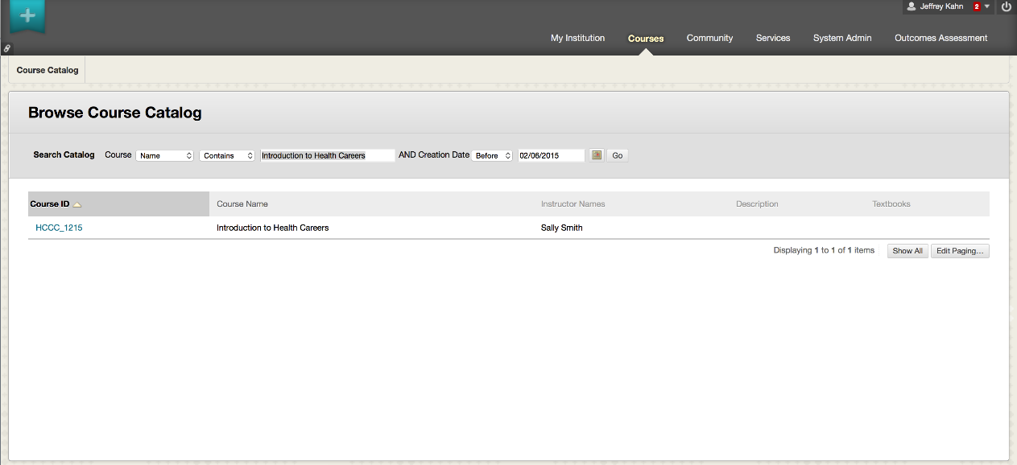

Here is a sample course catalog view with Jones teaching. Note that this is not simply the case of a change of instructor. This may be a new instructor using another instructor’s material in their course.

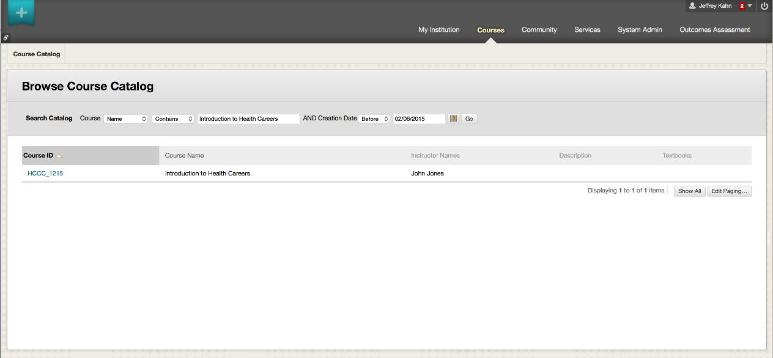

More visible than just a name change, here is a sample course catalog view with Smith teaching, but in a different LMS -- at a different school. Not only can the instructor’s name change, but the material can be at a different school.

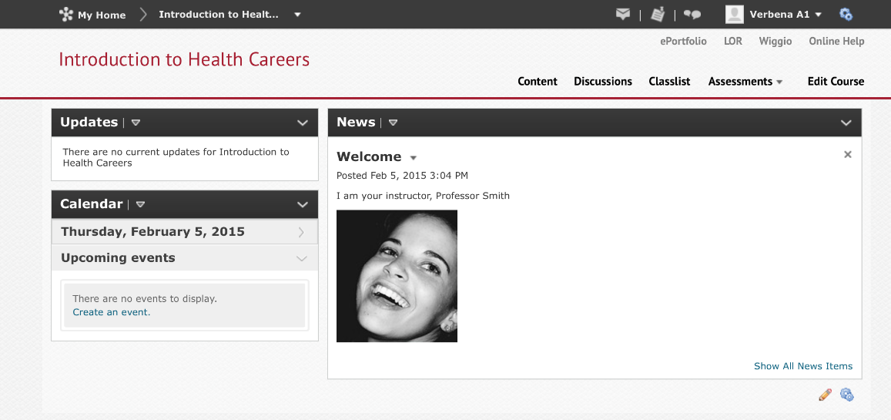
License by ViewMinder (https://www.flickr.com/photos/light_seeker/)
https://creativecommons.org/licenses/by-nc-nd/2.0

Now here is the “Jones” course -- someone else’s picture is associated with a course containing “your” material.

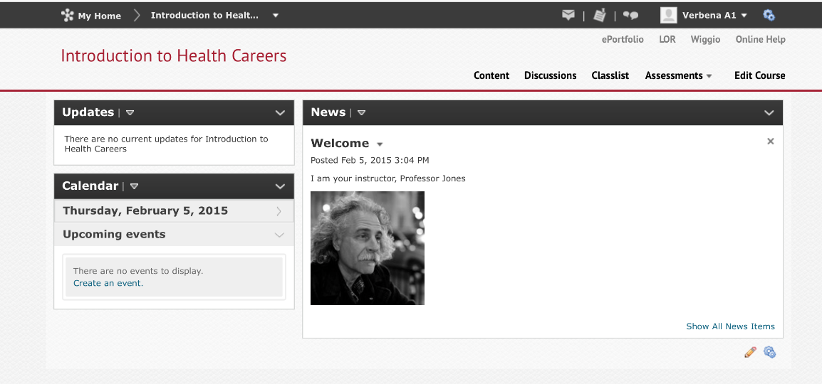
License by ViewMinder (https://www.flickr.com/photos/light_seeker/)
https://creativecommons.org/licenses/by-nc-nd/2.0

  - Adding contributed materials, in total and in sequence, to an existing course.

    - Authorship of each piece of material is distinct, but the course material selection and arrangement belongs to a single party. Jones wants to adopt Smith’s approach to a specific topic. The “Smith” approach is still readily distinguishable.

Here we have the “Smith” course on the left and the “Jones” on the right. Note 7 units of material, adopted wholesale and in sequence.
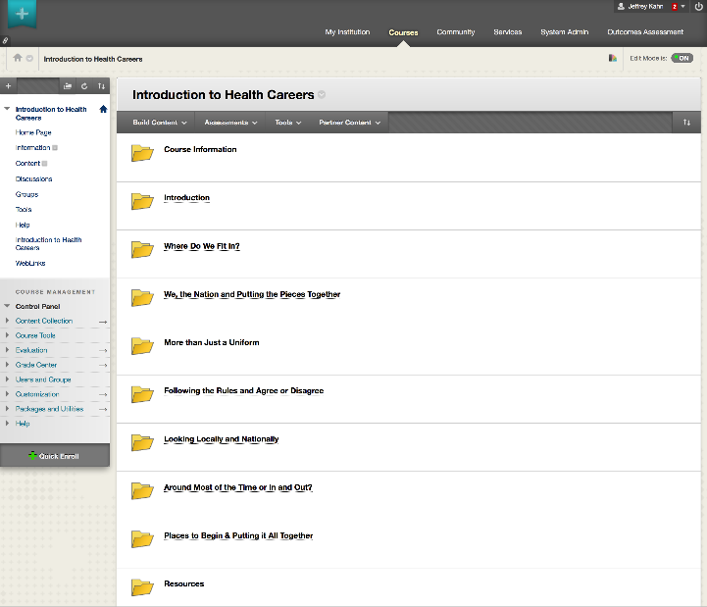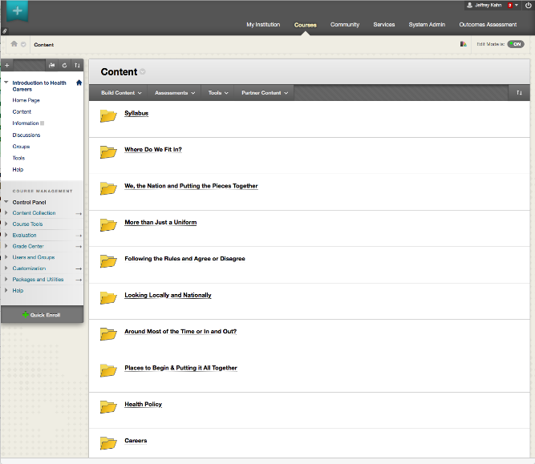

  - Intermixing contributed materials, in total, with other materials.
    - Similar to adding material as a block, but with a new pedagogical flow. Jones wants to adopt Smith’s material, but change the arrangement. The “Smith” approach may be hard to discern.

  - Adding or intermixing a subset of materials.
    - Jones wants to adopt only some of Smith’s material and weave it into a new pattern. The “Smith” material remains, but the “Smith” approach may be lost.

Here we have the “Smith” course with sub-unit “Where Do We Fit In?”

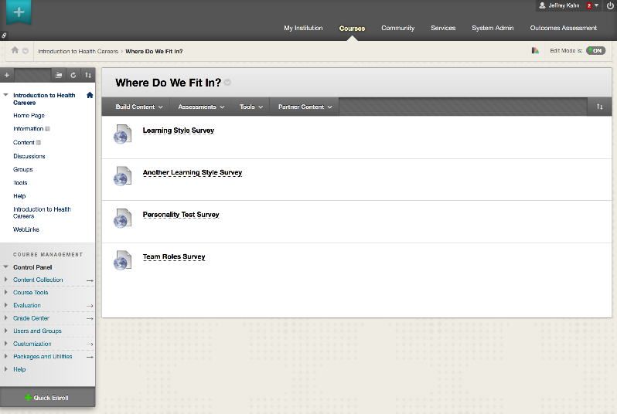

Here we have the “Jones” course with different material, but the unit “Where Do We Fit In?” sub-unit reused fully. The more changes, the looser the link to the original material.

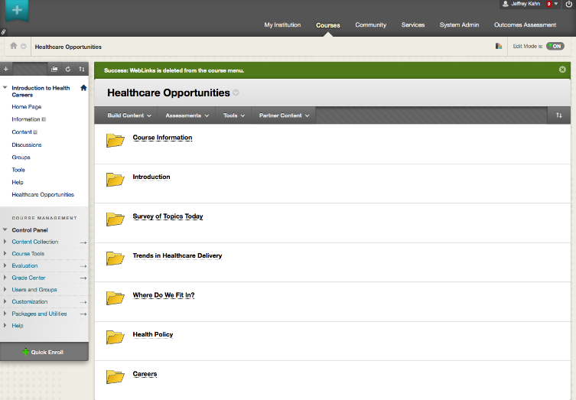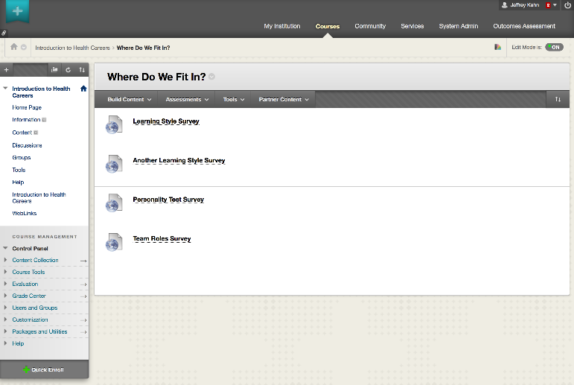

- Within a unit of material

  - Reordering content.
    - Jones adopted the material, but not the order.

  - Adding content.
    - Jones adopted the material, but felt more was needed.

  - Removing content.
    - Jones adopted only some of the material.

  - Intermixing other content.
    - Jones adopted only some of the material and wove in other materials to create a new arrangement.

  - Editing content.
    - Jones adopted some material, but made changes to the content beyond just the order.

- Reformatting material

  - Converting Microsoft Word to PDF, HTML, or EPub. For use on a mobile device, tablet, or served rather than downloaded.
    - This change may bring the material to a new audience.

  - Adding accessibility-related data such as captioning.
    - This change may bring the material to a new audience.

  - Editing a video, including making a clip that results in less context.
    - Jones adopts only a piece of the Smith content. Is the excised content essential or peripheral?

  - Reformatting or rearranging material to match a different aesthetic taste. This might involve changes to fonts, wrapping, layout, white-space, etc.
    - De gustibus non est disputandum.

  - Rewriting an assessment in QTI for portability; adding machine grading.
    - This can save labor for the grader.

  - Hosting assessment data in a system that will then send grades to an LMS grade book.
    - This can save labor for the grader.

  - Changing a question type such as using an interactive matching in place of a multiple-choice.
    - This may make material more engaging.

  - Packaging an LMS-specific course as an IMS Common Cartridge.
    - This can lower the barriers to adoption when Smith and Jones use different LMS platforms.

Sometimes the transformation from original material to its reused form can be quite dramatic. For example, here is an image of a paper-based math quiz.
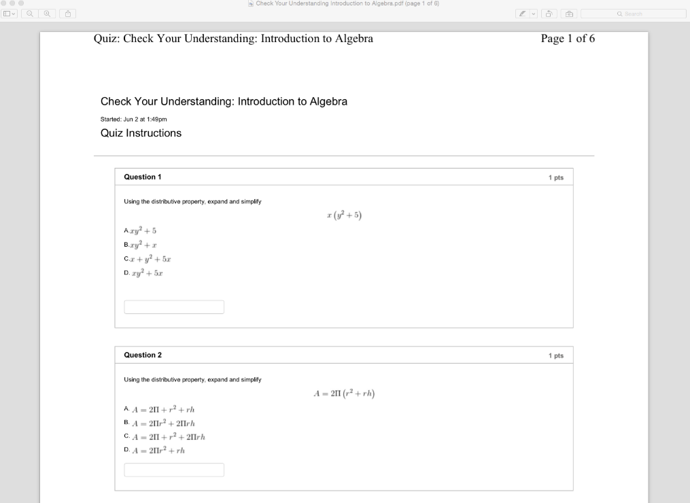

With no change to the questions themselves, the content is re-entered into an equation editor that is part of software to emit a website.

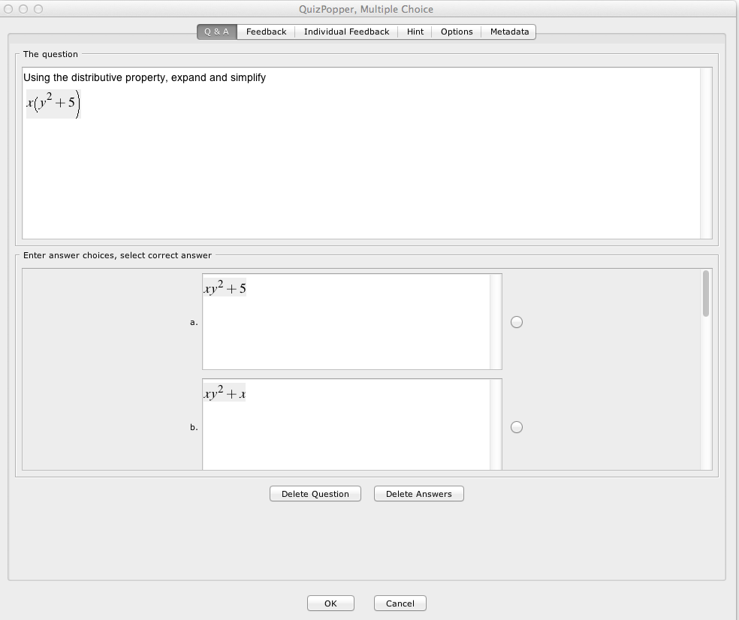

Now we see the same question content rendered as an interactive quiz on a school-branded website. What a change!

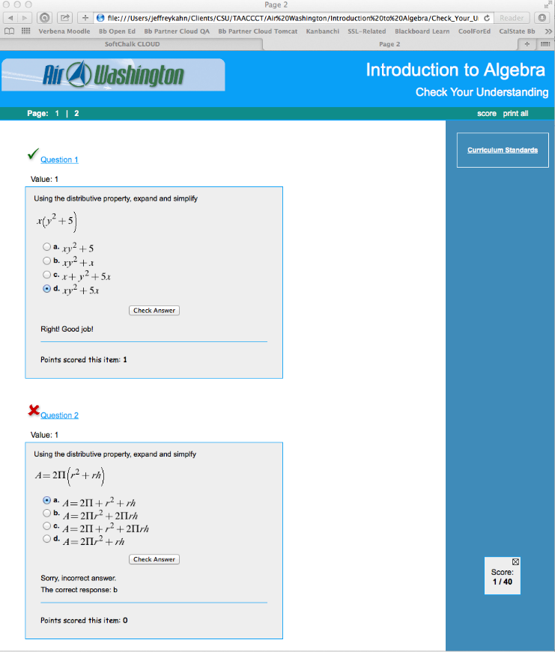
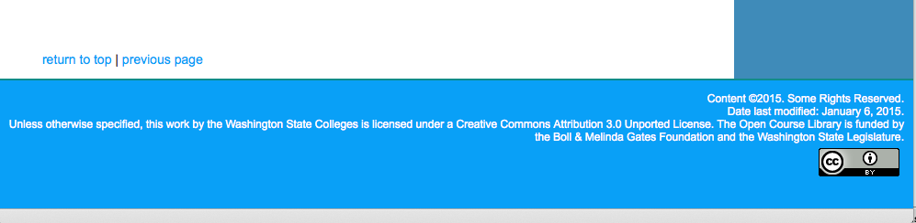

This work is licensed under a Creative Commons Attribution 4.0 International License.
This workforce solution was created through a cooperative agreement between the U.S. Department of Labor's Employment and Training Administration and the California State University-Multimedia Educational Resource for Learning and Online Teaching (MERLOT).

