Skills Commons Repository User Guide:

Documenting Your Description and Industry Partner in Learning Resources Materials
Welcome to the SkillsCommons Repository. This document was created to assist with the specific Description and Industry Partner fields in the submission process for the “Learning Resources Collection” within your Community. This document will cover the steps of adding submissions up to the Industry Partner field and provide specific examples of what is required for this field. Instructions for editing completed submissions in the Description and Industry Partner fields are also included.

ADDING (SUBMITTING) MATERIALS

- Type http://skillscommons.org/ into your browser address bar.
- Click “CONTRIBUTE” located in top menu navigation of the SkillsCommons Repository website.
- Sign in to the SkillsCommons Repository using the e-mail address and password you were provided.
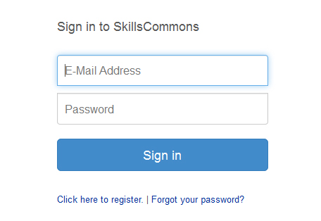
- Once you have signed in click on the “start a new submission” link.
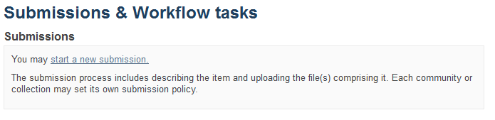
- Select the “Learning Resources Collection” from the “Collection” dropdown menu and click “Next” to start your submission.
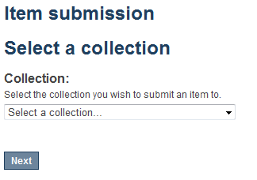
- Entering your Item Description – PAGE 1
The single item submission process is a six step process that allows you to enter all the metadata about your material, upload the associated files, review your submission, and finally submit the item to the repository. Enter as much information about the item as you can in order to help others find it in the repository. Each field has a brief description of the data you should enter into the field. The following pages provide some additional information about each field.
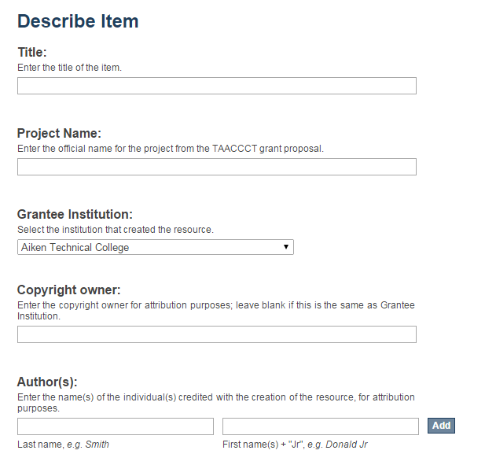
Project Name: Enter the official name of your grant project if it is different from the name on your TAACCCT grant proposal.
Grantee Institution: (REQUIRED FIELD) Select the name of the institution that created the resource.
Author(s): To add multiple authors click the “Add” button.
Copyright owner: Enter the copyright owner for attribution purposes; leave blank if this is the same as Grantee Institution or Consortium.
Title: (REQUIRED FIELD) Enter the title of the item.
(continued on next page)
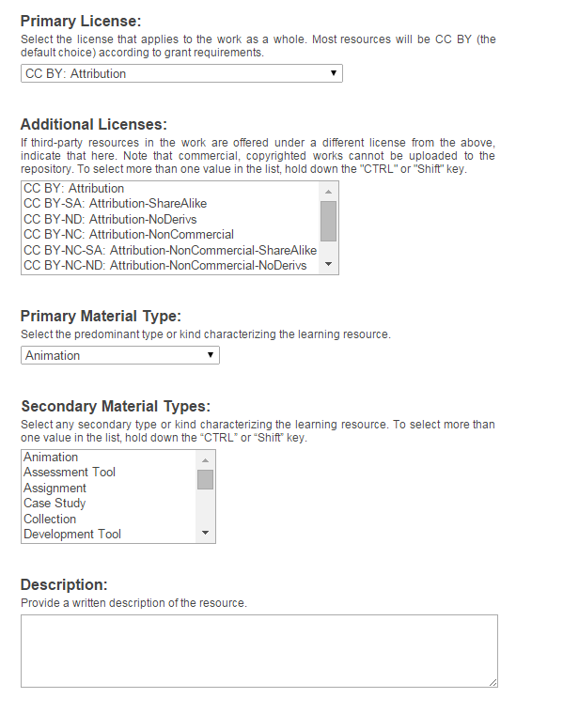
Additional Licenses: If third-party resources in the work are offered under a different license from the above, indicate that here. Note that commercial, copyrighted works cannot be uploaded to the repository. To select more than one value in the list, hold down the "CTRL" or "Shift" key.
Primary License: (REQUIRED FIELD) Select the license that applies to the majority of items in the work. Most resources will be CC BY (the default choice) according to the grant requirements.
Secondary Material Types: Select any secondary type or kind characterizing the learning resource. To select more than one value in the list, hold down the “CTRL” or “Shift” key.
Primary Material Type: (REQUIRED FIELD) Select the predominant type or kind of material characterizing the learning resource.

Description: (REQUIRED FIELD) Use this field to describe the material in as much detail as possible so others can find it when searching the repository. A detailed description also helps users decide if it is an appropriate material for their use. Be as specific as possible so others can understand what the material is about. Please see below for specific examples.

(continued on next page)

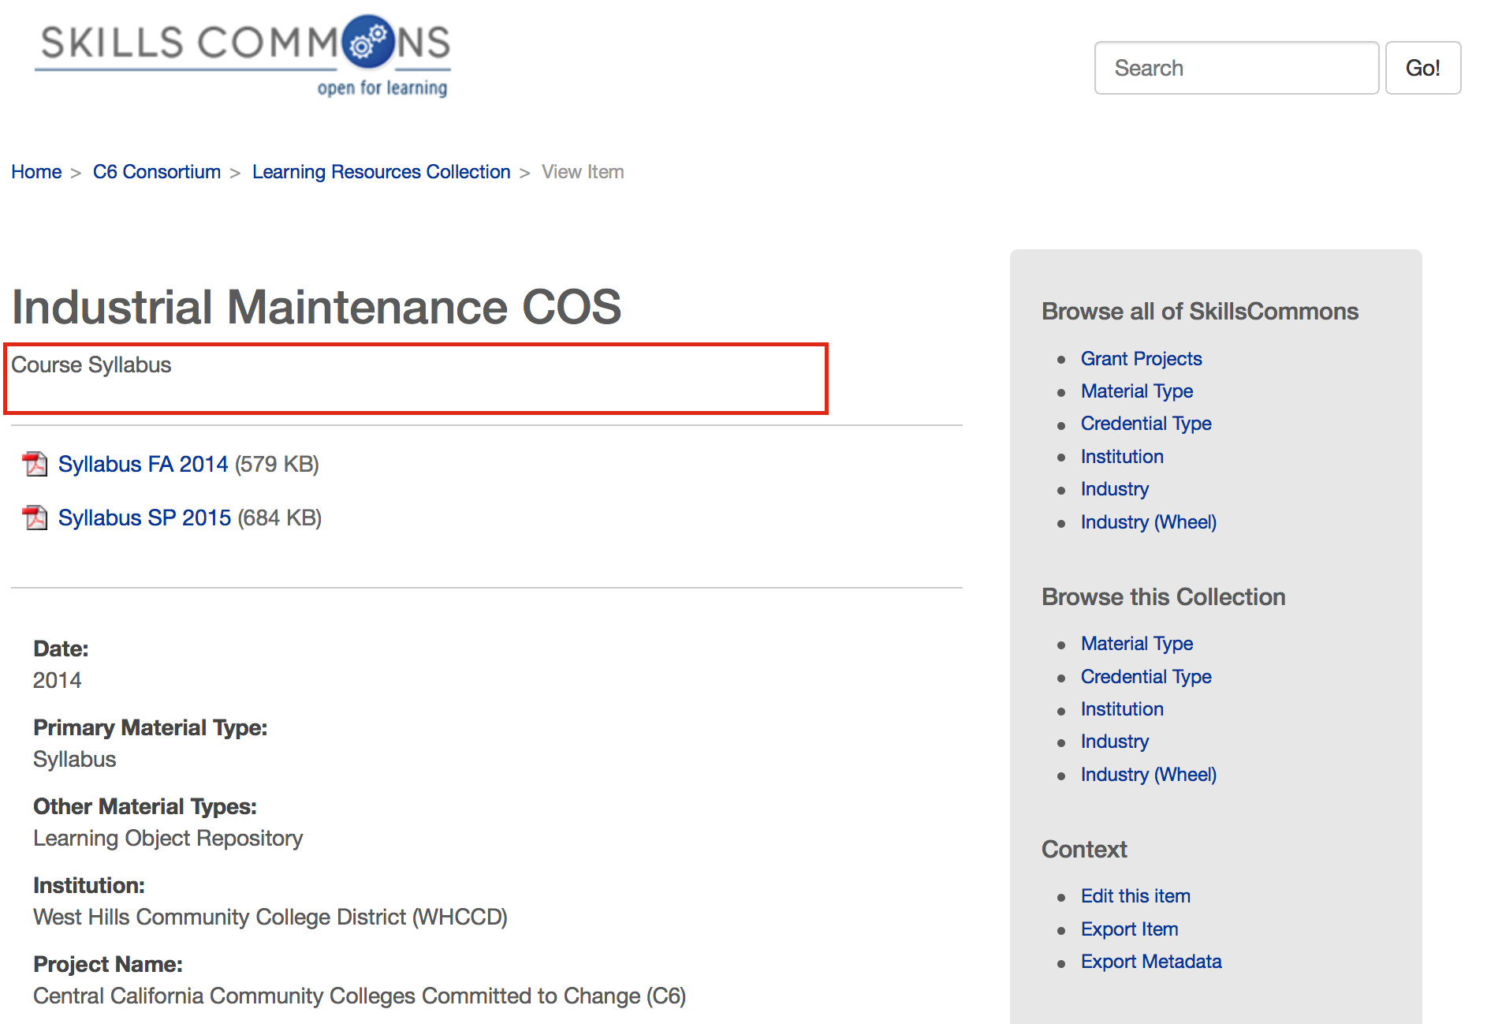
This example, “Course Syllabus” needs to provide more detail about the material. For example, “This is a two semester program in Industrial Maintenance Technology. The syllabi contain the course objectives, student learning outcomes, list of assignments and names of the course textbooks.”
(continued on next page)

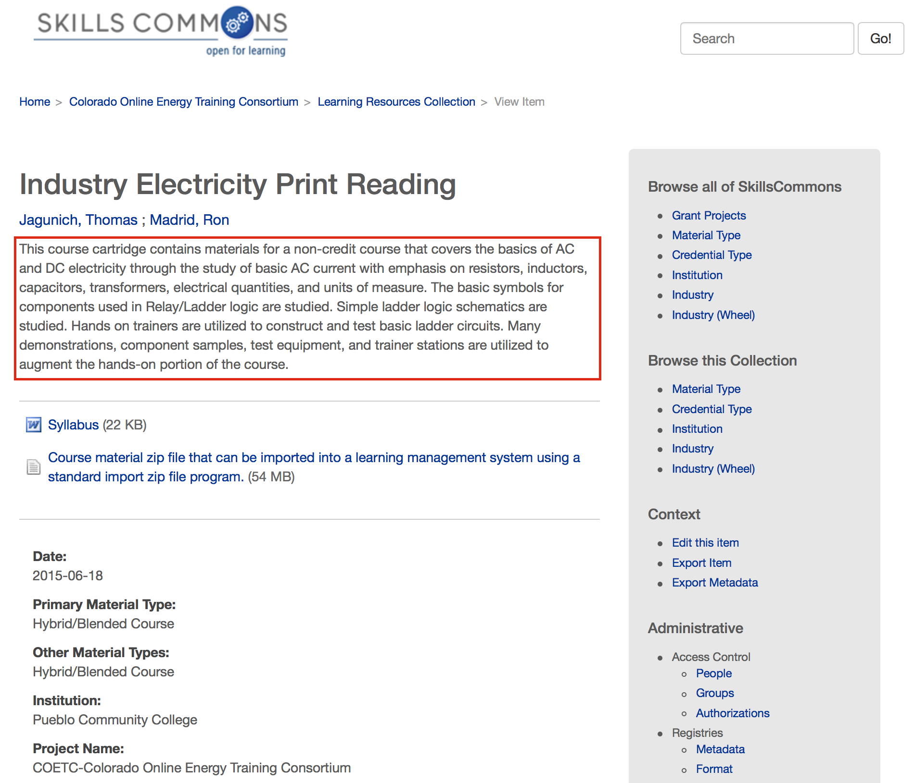
This example, “This course cartridge contains materials for a non-credit course that covers the basic of AC…” provides a detailed description about the material. Users are given enough information to decide if this material is appropriate for their use.

(continued on next page)

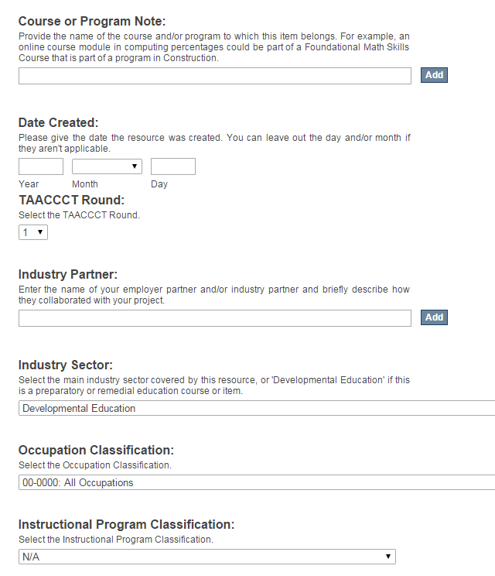
Industry Partner: (REQUIRED FIELD) Enter the name of your employer partner and/or industry partner and briefly describe how they collaborated with your project. Please see below for specific examples.
Course or Program Note: Provide the name of the course and/or program to which this item belongs. For example, an online course module in computing percentages could be part of a Foundational Math Skills Course that is part of a program in Construction. Click the “Add” button to add more than one.
Date Created: (REQUIRED FIELD) The “Year” field is required.
TAACCCT Round: (REQUIRED FIELD) Enter the TAACCCT Round the resource was created for.
(continued on next page)
REQUIRED FIELD: Select the predominant mode of learning supported by the learning resource.
REQUIRED FIELD: Select the educational level of the instructional material(s); To select more than one value in the list, hold down the “CTRL” or “Shift” key.
REQUIRED FIELD: Select the type of credential to which this learning resource was originally applied. To select more than one value in the list, hold down the "CTRL" or "Shift" key.
Click “Save & Exit” if you would like to return later to complete the submission. Click “Next” to continue on to PAGE 2 of the material description process.

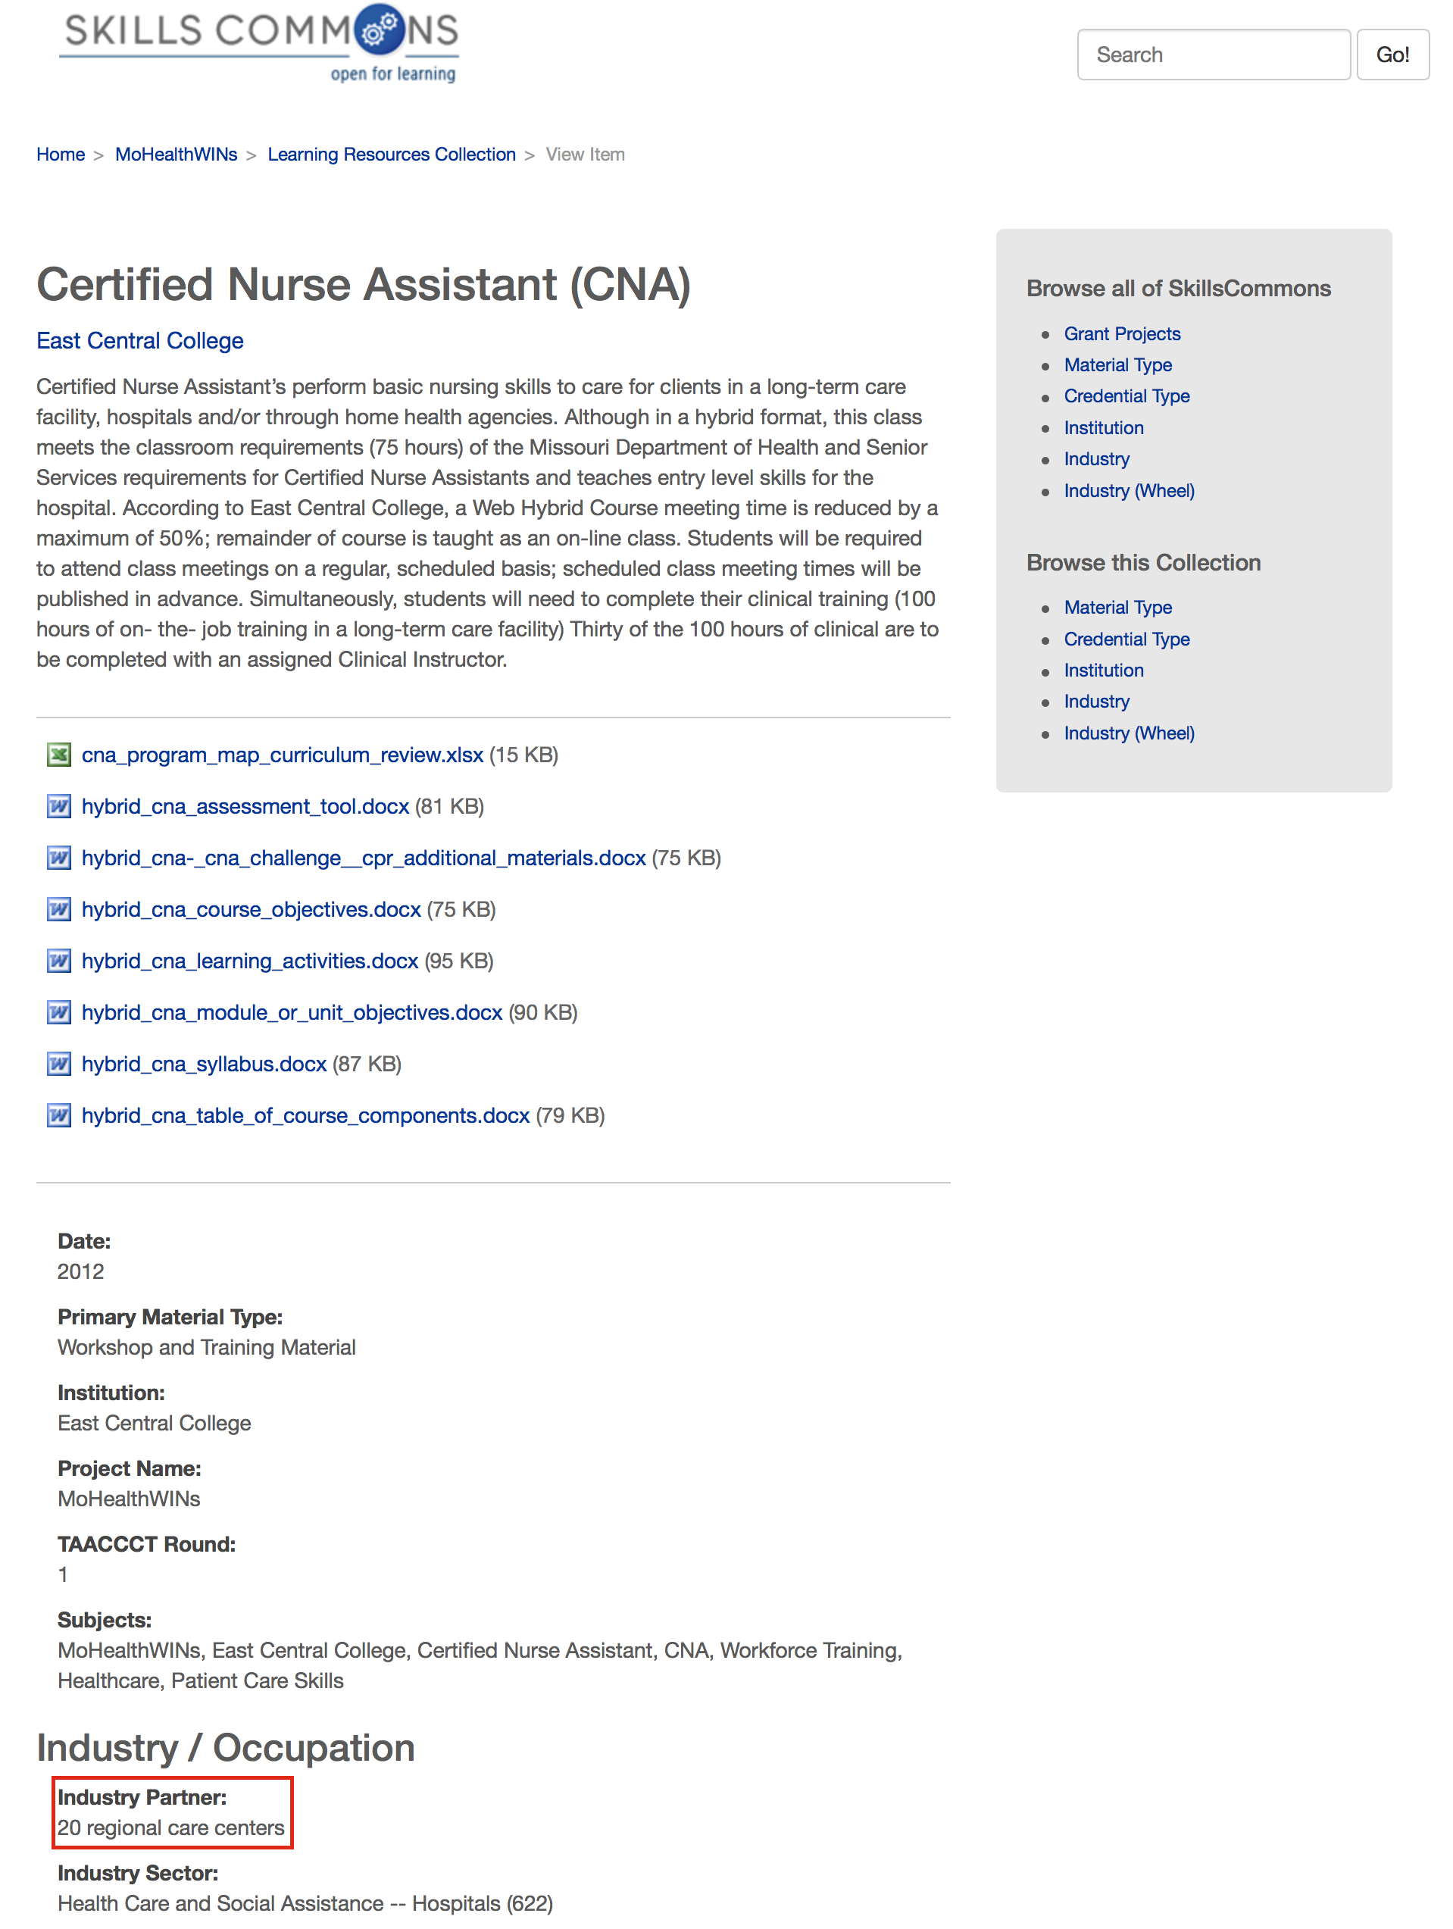
This example, “20 Regional care centers” needs to be more specific. A specific employer partner and/or industry partner needs to be named.
(continued on next page)
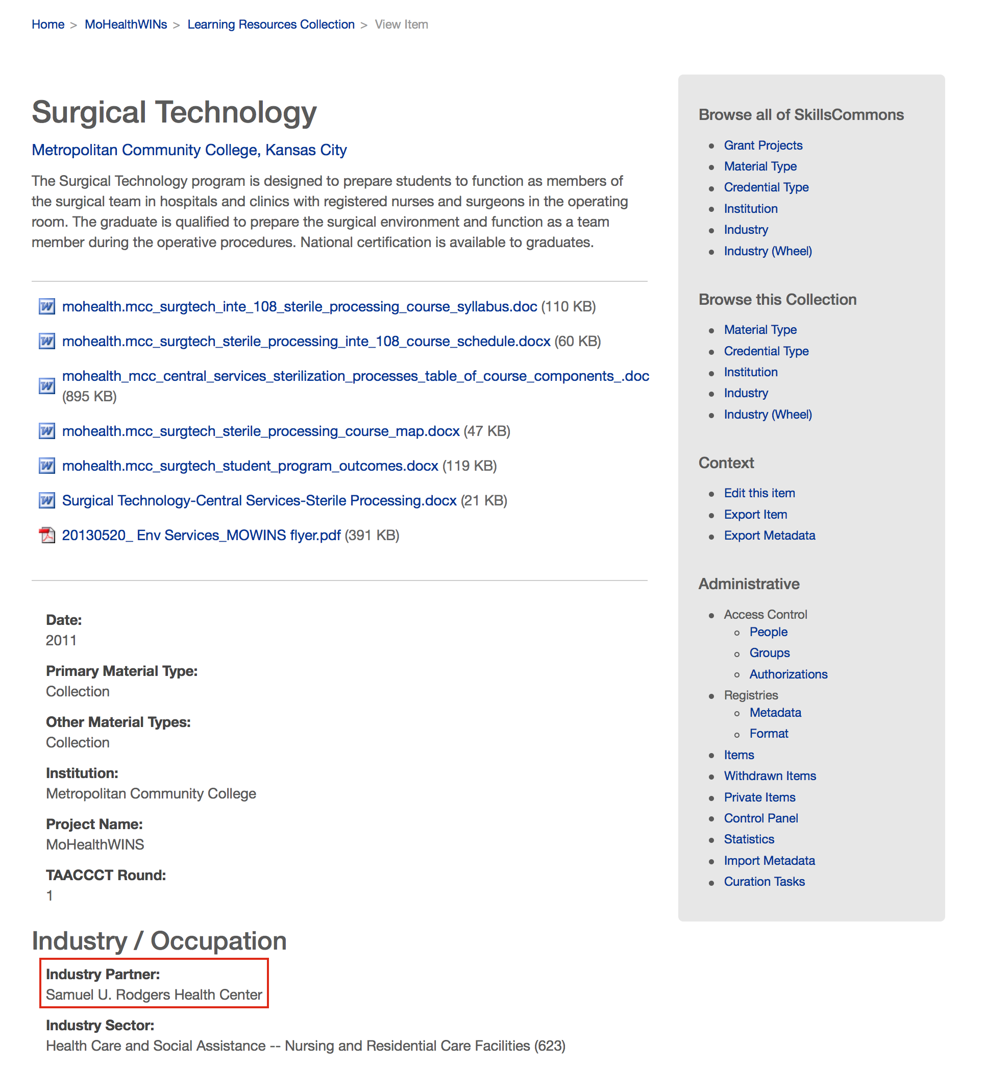
This example, “Samuel U. Rodgers Health Center” is specific. The name of the employer partner and/or industry partner is identified.

EDITING AN ITEM IN THE REPOSITORY

- Type http://skillscommons.org/ into your browser address bar.
- Click “CONTRIBUTE” located in the top menu of the SkillsCommons Repository website.
- Sign in to the SkillsCommons Repository using your e-mail address and password.
- Once you have signed in click on the submission you wish to edit.
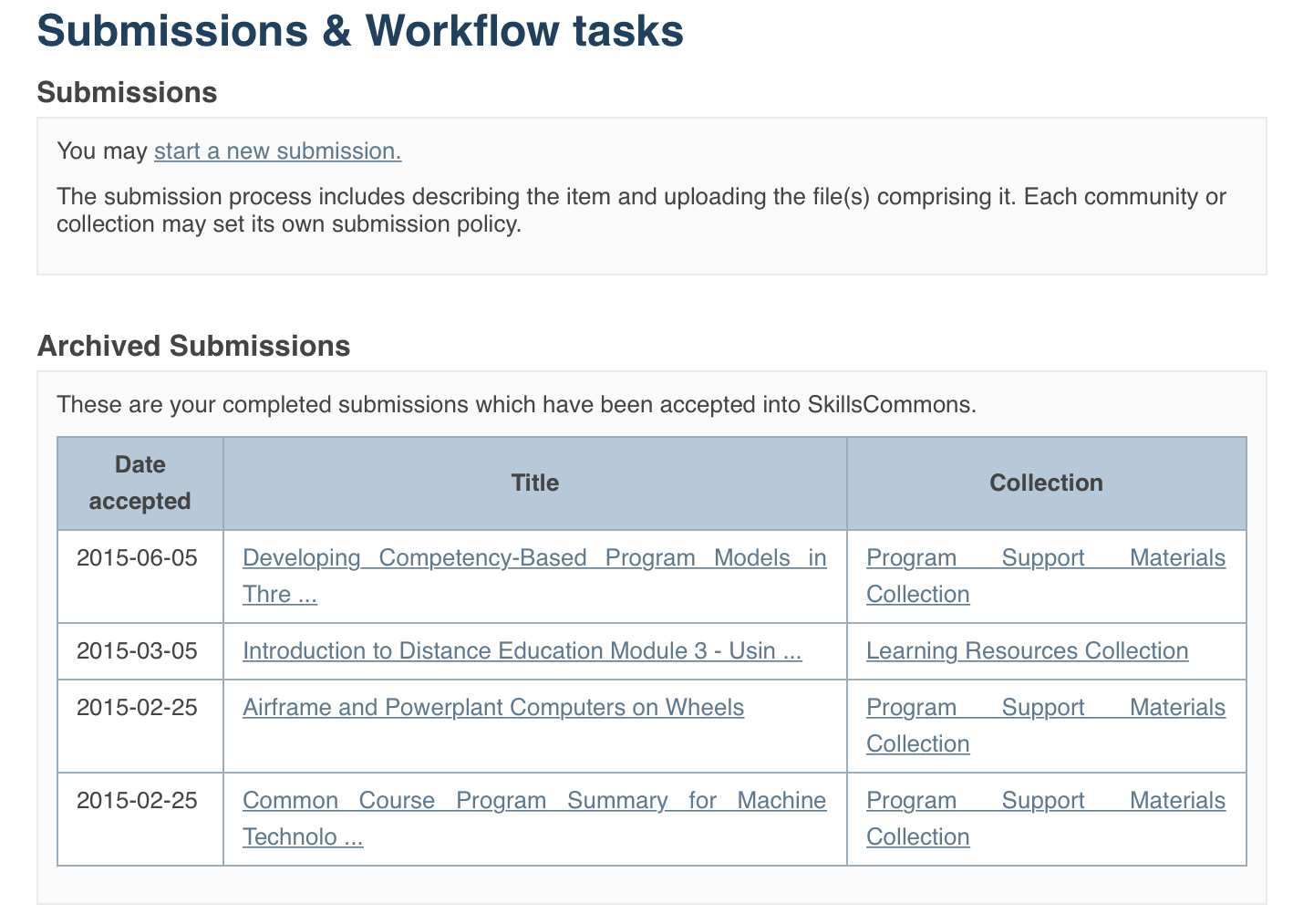
- You are now on the item page. To edit this item click on “Edit this item” under the “Context” heading.
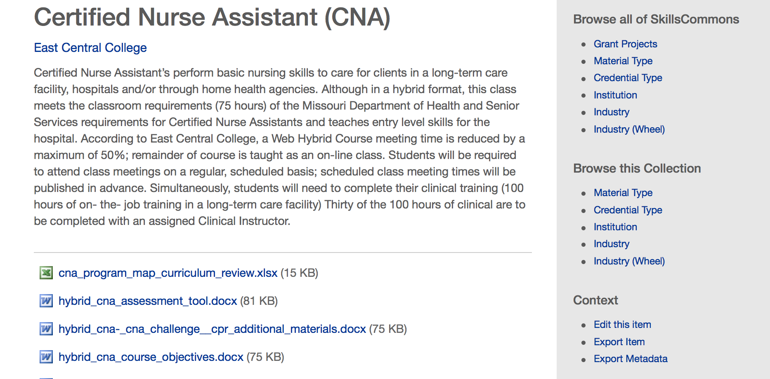
Click on “Edit this item” under the “Context” heading
- After clicking on “Edit this item” you will be presented with the screen below. Click on the “Item Metadata” tab to edit the fields in this item.
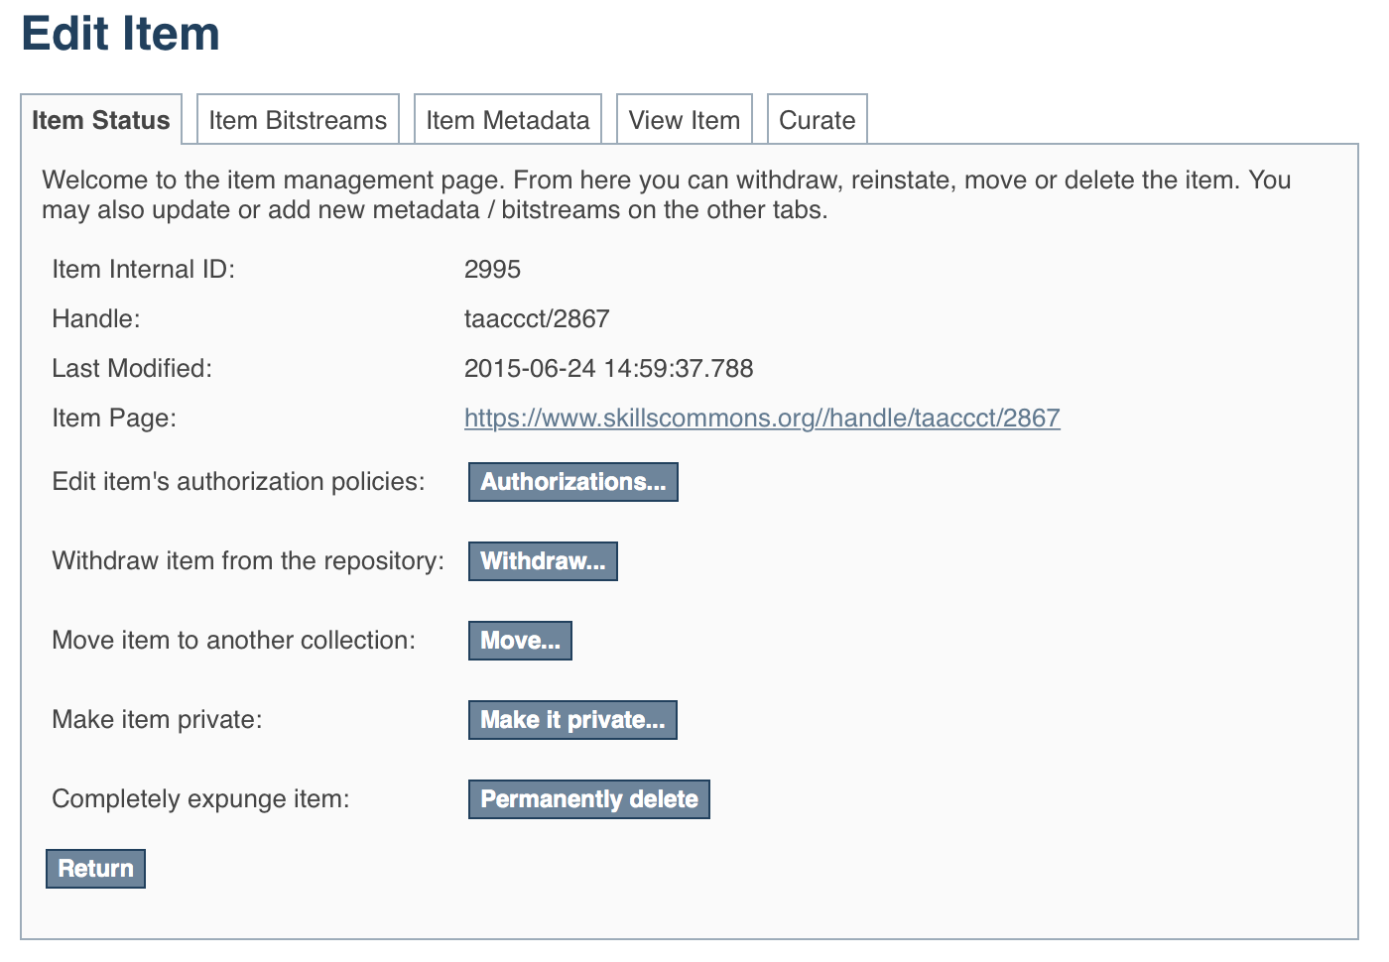
Click on “Item Metadata” to edit the fields in this item.

- After clicking “Item Metadata” you will be presented with the full Metadata record. This record will show you the fields that you initially entered when you first submitted the item.
PLEASE NOTE: These changes are not validated in any way. You are responsible for entering the data in the correct format. If you are not sure what the format is, please do NOT make changes. If you need assistance making edits please contact our support staff at support@skillscommons.com.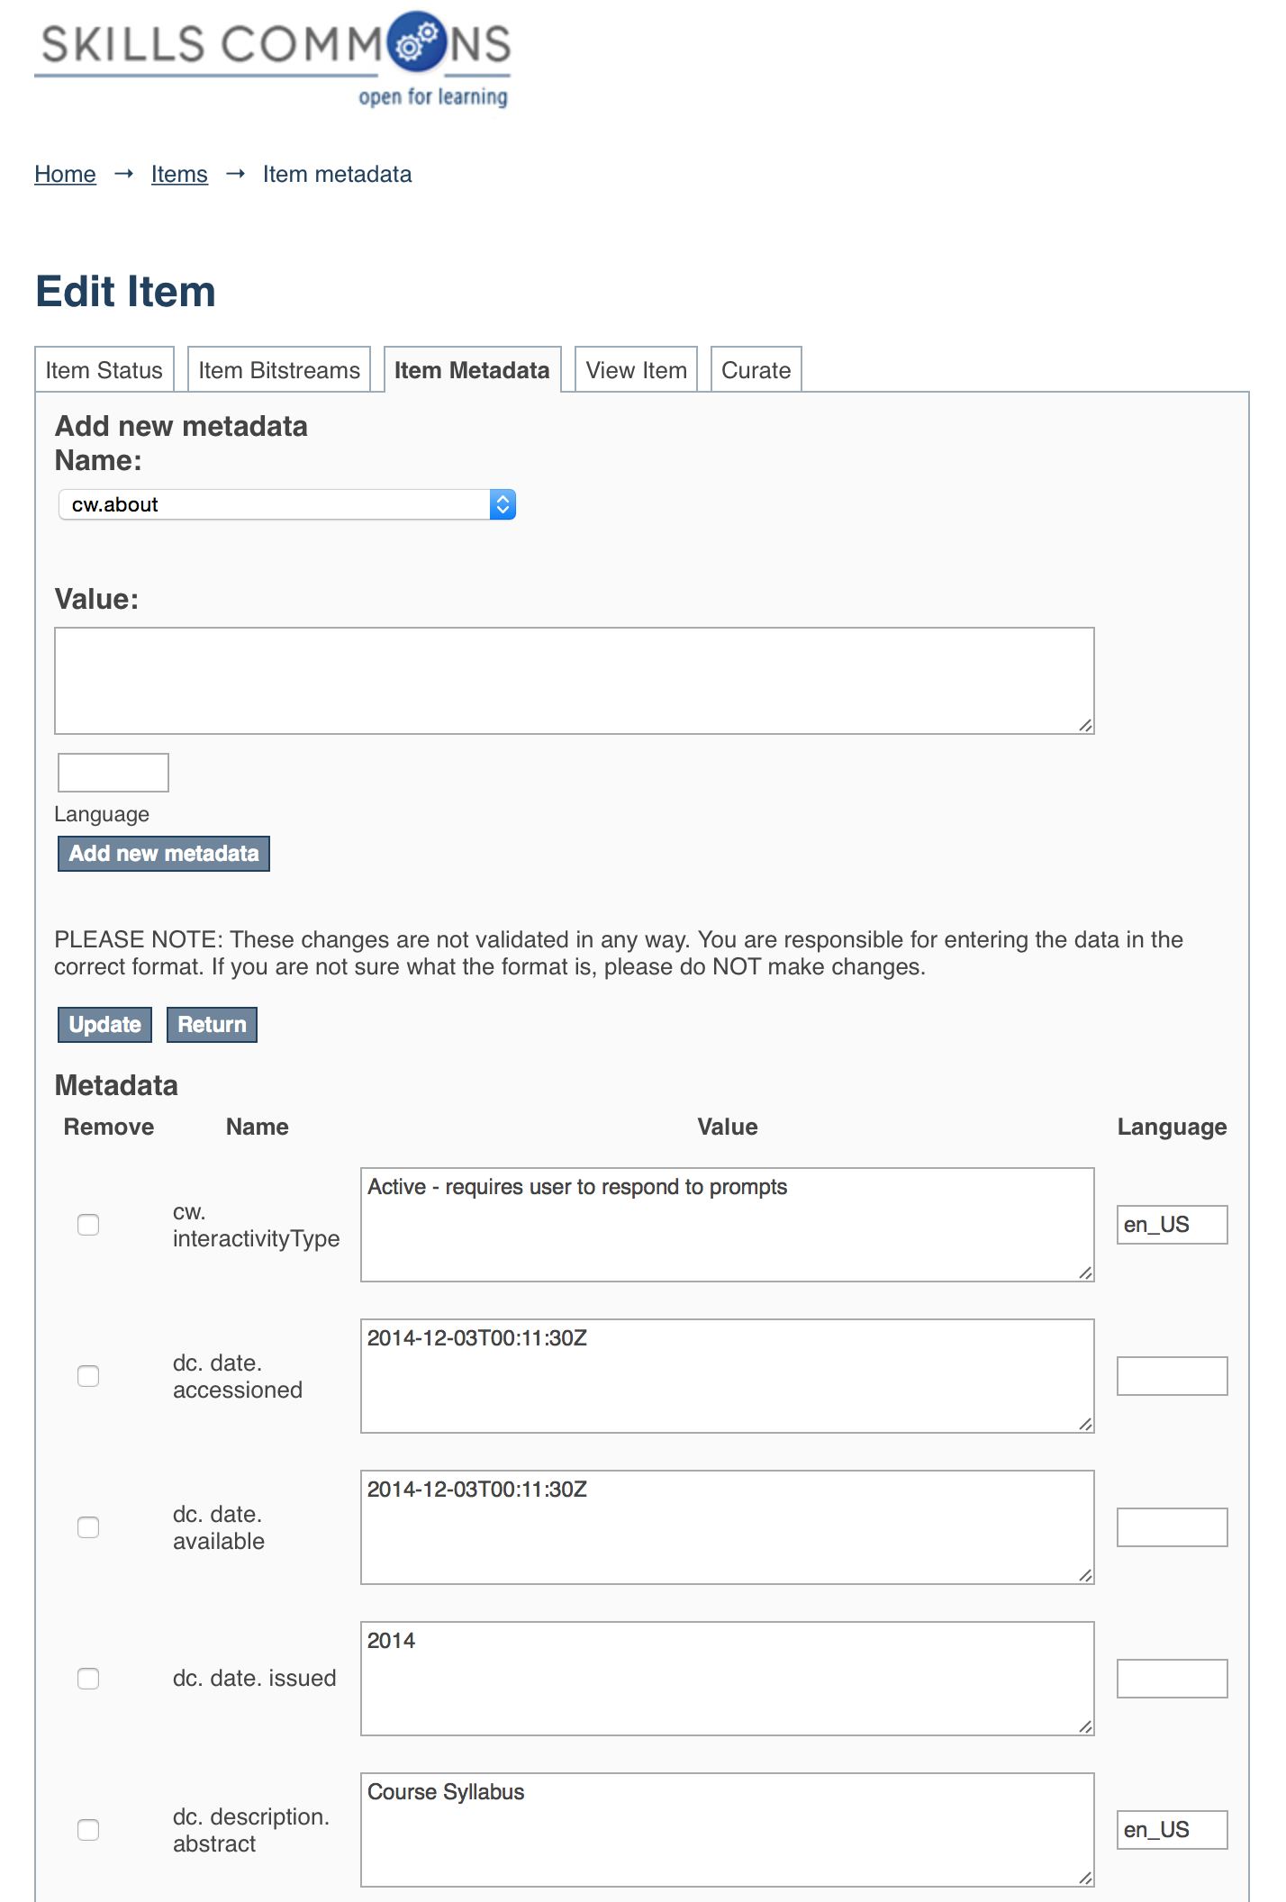
To update the Description Field that you already entered, scroll down and find the “dc. description. abstract” field you wish to update and type the new information.
Be sure to click on the “Update” button found at the top or bottom of the page.

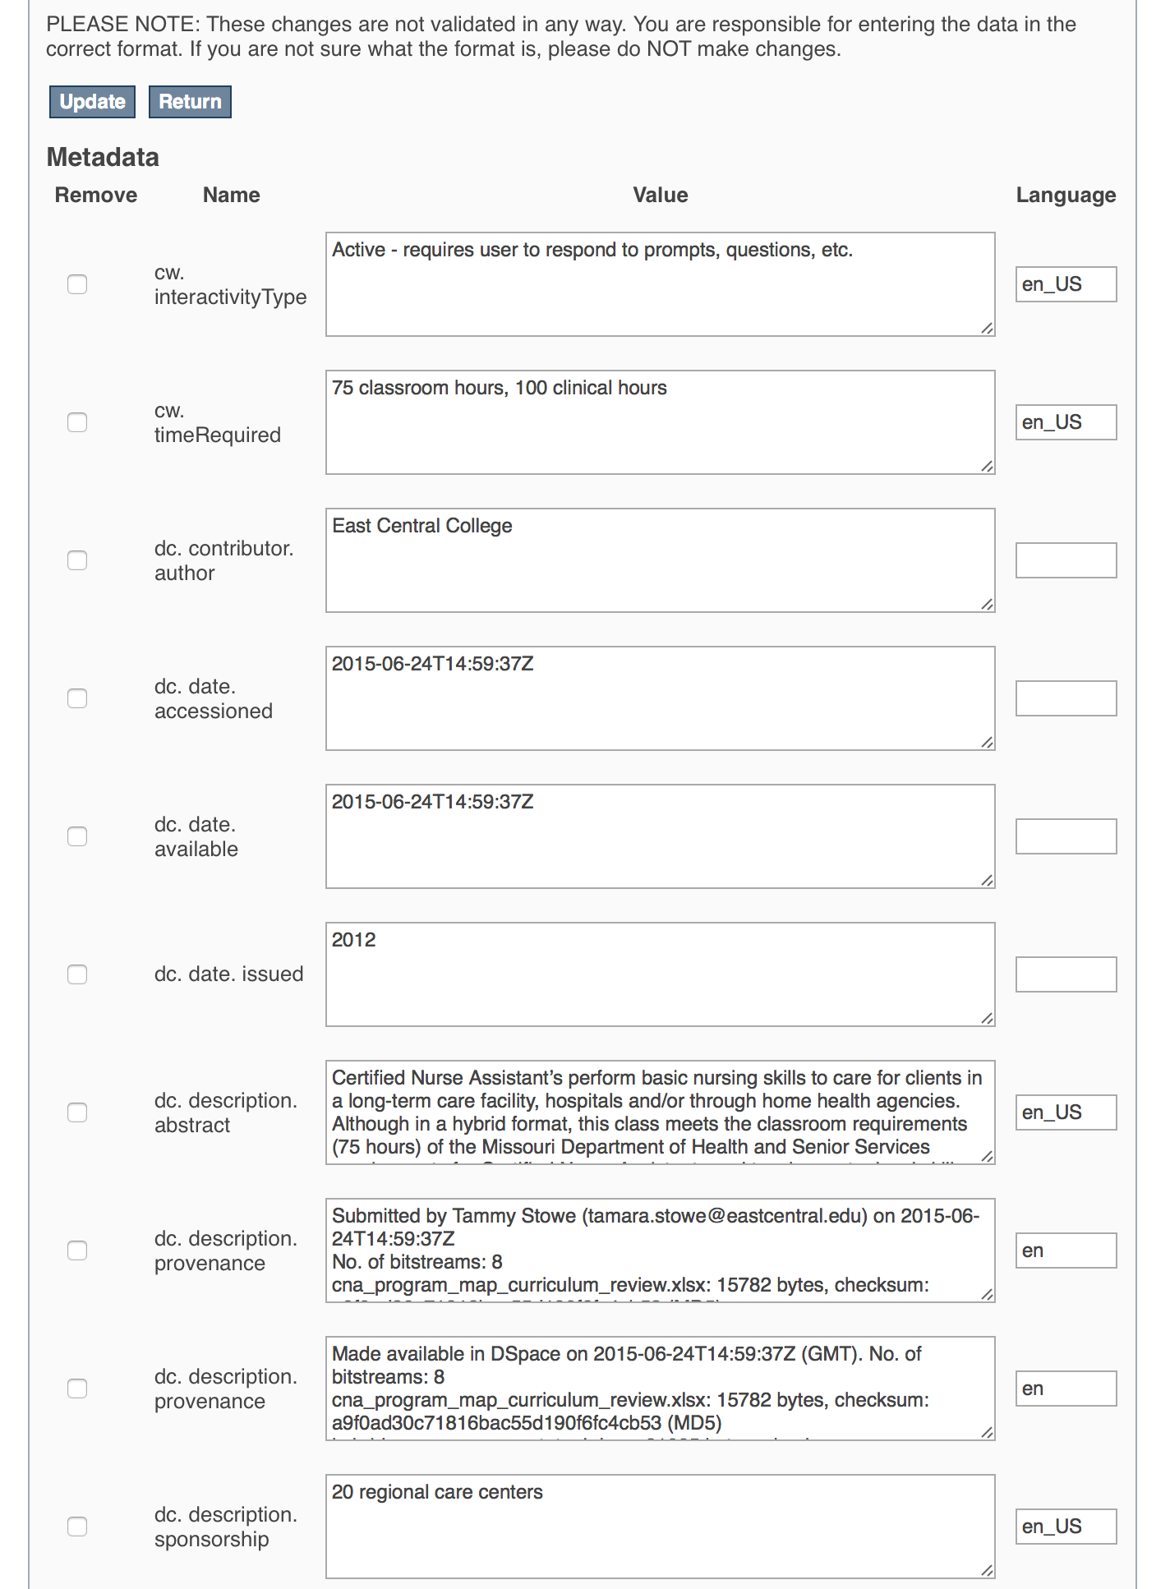
To update the Industry Field that you already entered, scroll down and find the “dc. description. sponsorship” field you wish to update and type the new information.
Be sure to click on the “Update” button found at the top or bottom of the page.

This work is licensed under a Creative Commons Attribution 4.0 International License.
This workforce solution was created through a cooperative agreement between the U.S. Department of Labor's Employment and Training Administration and the California State University-Multimedia Educational Resource for Learning and Online Teaching (MERLOT).

