Assess the Accessibility of PDFs

Table of Contents
Introduction 2
Text Access 2
Reading Order 2
Structural Markup and Navigation 2
Tables 2
Hyperlinks 2
Color as Information 2
Color Contrast 2
Language 2
Images 2

Introduction
Use this document to determine the accessibility of PDFs.

Tools
The list below contains links to the applications used in this tutorial to assess PDFs:
- Natural Reader
- PDF Accessibility Checker (PAC)
- Colour Contrast Analyser (CCA)
- Adobe Reader

Further Assistance
If the PDF being assessed does not meet one or more of the accessibility criteria described below, please consult with the campus office serving students with disabilities for assistance in obtaining an accessible version of the PDF. Providing this access in a timely manner is critical for student success.

Text Access
Text access allows users to enable text-to-speech functionality so that the text may be read aloud.

What to do
Listen to the text

Tool(s) to use
Adobe Reader and Natural Reader

How to use
- Open the PDF in Adobe Reader

- Open Natural Reader.
- Select the Floating Bar button.
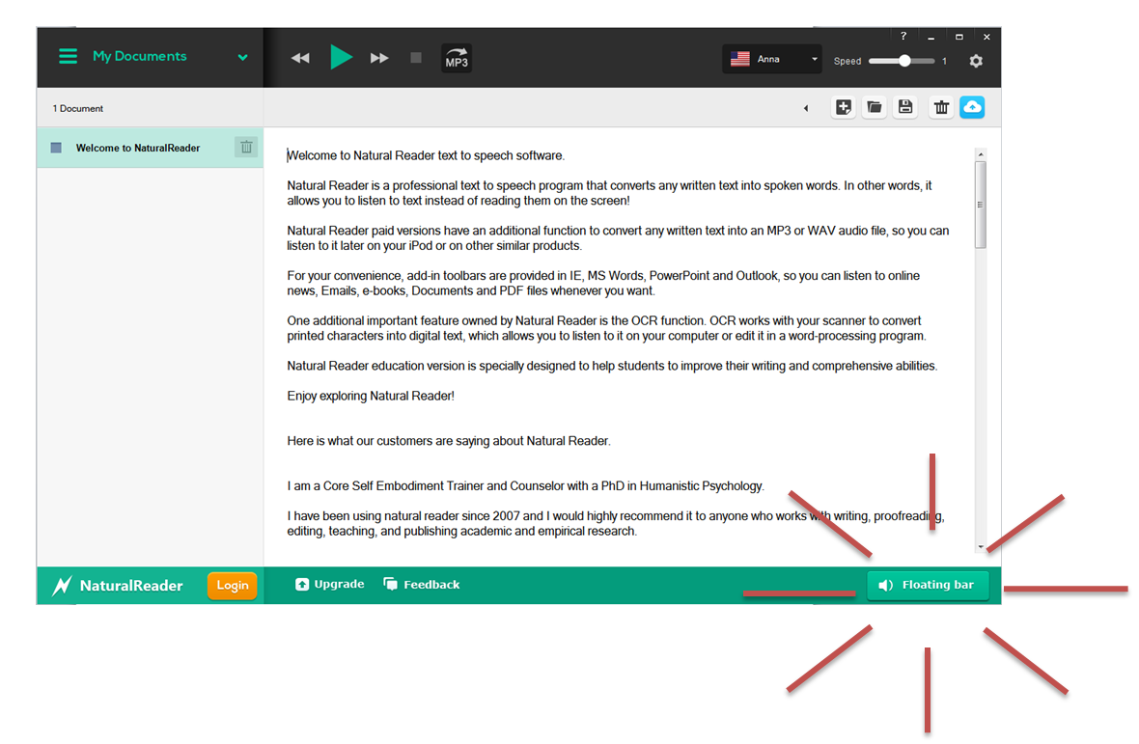

- Select text in the material to be read aloud.
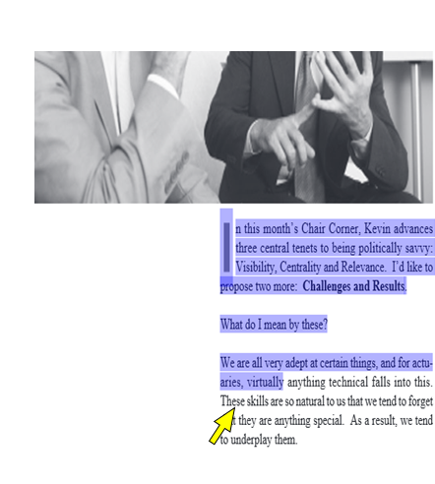
Note: If the text is selectable letter by letter, then this is a good indication that the text is digital.

- If needed, enable the computer’s sound and adjust it to a safe volume level to listen to Natural Reader.

- On the Natural Reader Floating Bar, select the Play button to hear the text read aloud.
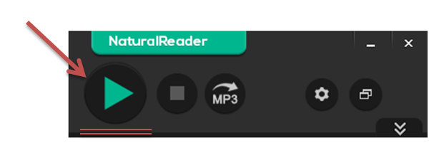

What is the Result?
If the text can be heard using Natural Reader, then it is digital text that assistive technology may be able to access.
If the text is not selectable or cannot be read aloud by a Text to Speech technologies such as Natural Reader, then the text is not digital and assistive technologies may not be able to access that information.

Reading Order
Reading order corresponds to visual layout.

What to do
Check the reading order

Tool(s) to use
Adobe Reader’s Read Out Loud Tool

How to use
Adobe Reader has a built in text to speech reader called Read Out Loud. Read Out loud will read the order of content based on its structure.
- Save the PDF on the computer
- Open the PDF in Adobe Reader
- The Read Out Loud features are located in the View menu under the Read Out Loud submenu.
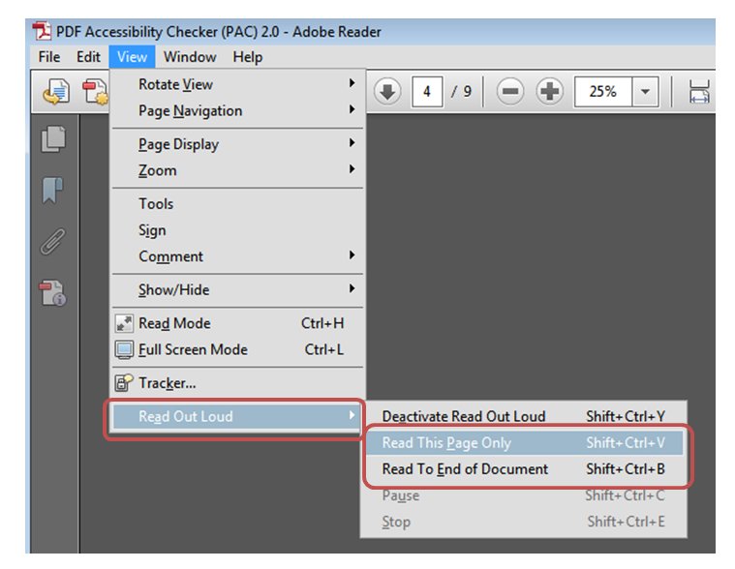
- Select Activate Read Out Loud
- Select options to Read This Page Only or Read To End of Document

What is the Result?
If the order of the content read by Read Out Loud matches the order of the content in the PDF, then the content will be conveyed to assistive technology users in a logical order.
If the order of the content read by Read Out Loud does not match the order of the content, then the content will be conveyed to assistive technology users in the wrong order.

Structural Markup and Navigation

The document includes structural markup, such as headings and lists, which can be used for navigation by assistive technology.

What to do
Assess the structure of the document by looking for headings, lists and tables.

Tool(s) to use
PDF Accessibility Checker (PAC)

How to use it
- Save the PDF on the computer
- Open the PDF Accessibility Checker
- Select the Browse button and select the saved PDF
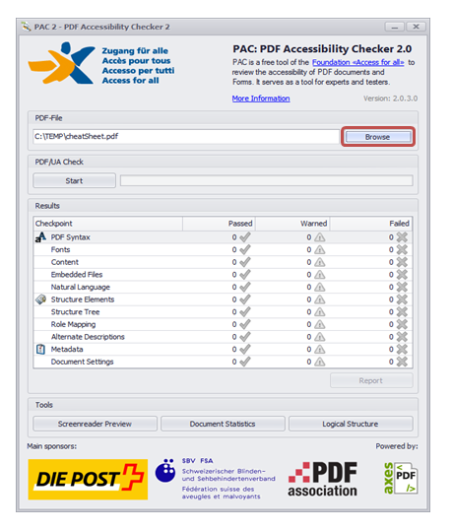
- Select the Start button
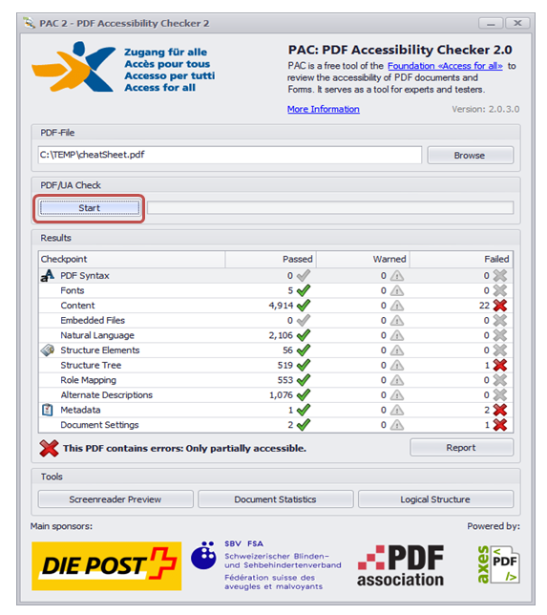
- Select the Logical Structure button
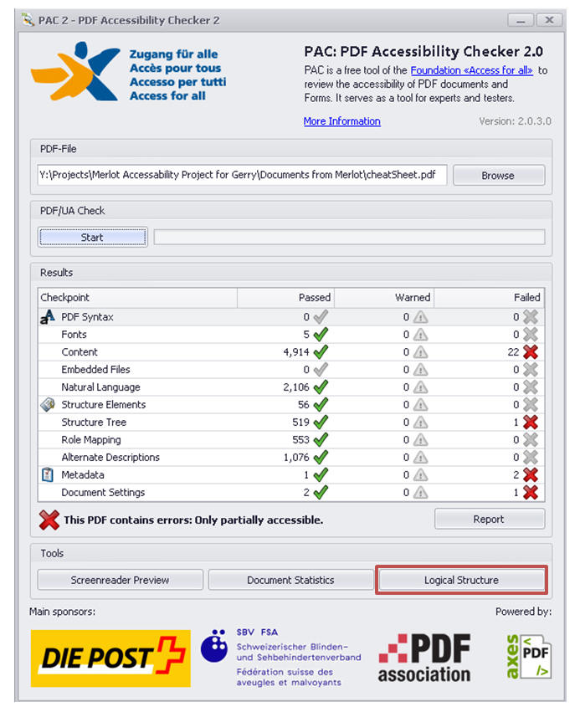

- Select the Page View tab
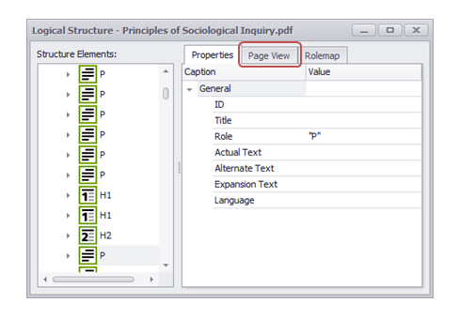
- Use the keyboard’s down and up arrow keys or use the mouse to move through each element in the Structure Elements section. Observe the highlighted content and its corresponding element.
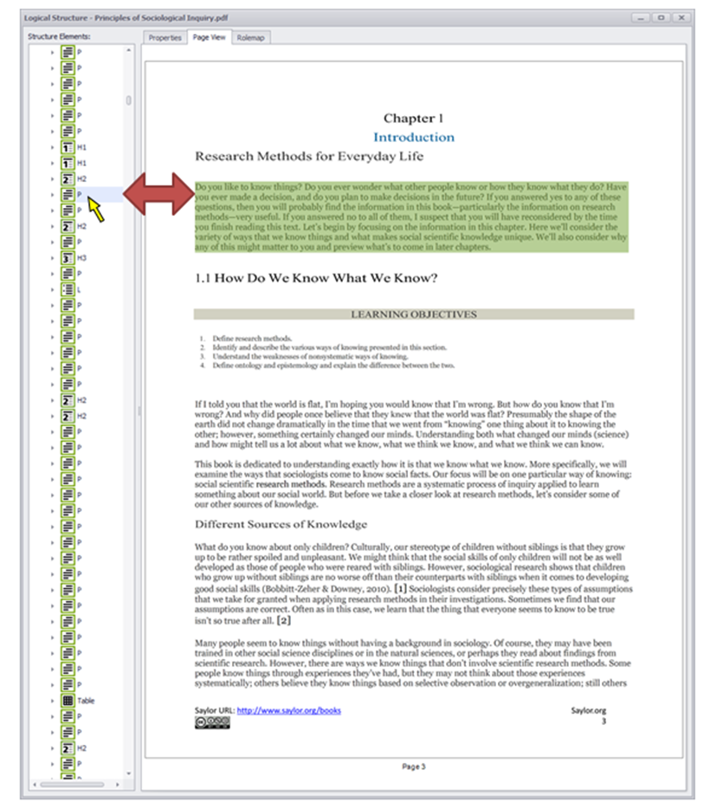

What is the Result?
The structural markup may be used for navigation if the content type in PAC’S Page View is represented in Structure Elements pane:
- - Heading 1
- - Heading 2
- - Heading 3
- - Paragraph
- - List
- - Table
The structural markup may not be used for navigation if the content type in PAC’S Page View is not correctly represented in Structure Elements:.
For example, if the Paragraph icon is the only element that appears in the Structure Elements: pane when headings and lists are apparent in the Page View, assistive technology users will not have the structure of the content correctly conveyed to them. These readers may miss the importance of the content in the document.

Tables

Data tables include markup that identifies row and column headers.

What to do
Assess the structure of the tables in a PDF.

Tool(s) to use
PDF Accessibility Checker (PAC)

How to use
- Save the PDF on the computer

- Open the PDF Accessibility Checker
- Select the Browse button and select the saved PDF
- Select the Start button

- Select the Logical Structure button

- Select the Page View tab
- Scroll to the section of the document that contains a table and expand the nested lists in Structure Elements: to display the table structure. Each corresponding part of the table will highlight in the Page View.
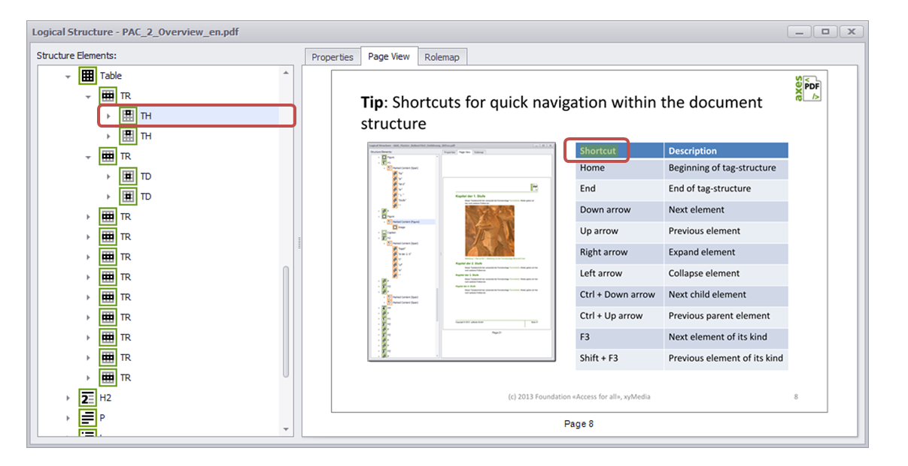

What is the Result?
The PDF has proper structural markup for its tables that can be used for navigation if the following icons are present (when applicable):
- Table
- TH - Table Header used for data table headers
Assistive technology users may be able to navigate through properly structured tables.
The page does not have a proper structural markup for tables if:
- Layout tables, tables that do not have relational data, have table headers.
- Data tables, tables with interrelated information, do not have headers.
Users of assistive technology may not be able to navigate through the table and may not understand its content.

Hyperlinks

Allows users to understand a link’s destination and what the name of the resource is that they are linking to.

What to do
Verify that links have a recognizable meaning and are functional.

Tool(s) to use
Adobe Reader

How to use
- Open the document in Adobe Reader
- Browse through the document and look for links.
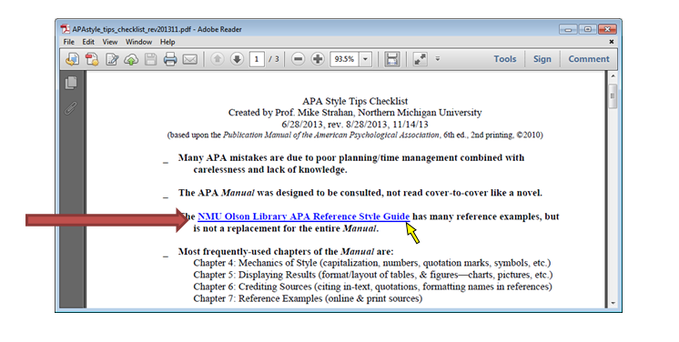
http://library.nmu.edu/guides/userguides/APAstyle_tips_checklist_rev201311.pdf
- Manually check the links by selecting them.
- Verify that the link goes to the expected destination. A well labeled link provides the user with information such as a meaningful name of a document, or name of a website.

What is the Result?
All users may be able to use the links included in a document if they are understandable and work properly. The hyperlinks in a document are operable and understandable if:
  - The links go to their appropriate destination.
  - The link text for the link clearly states where it will lead. A link labeled “Word doc” does not tell a person where it is linking to, especially when taken out of context of the text around it.
Below is a list of links that do not have meaningful names:
“Click here”
“Next document”
“New document”
“here”
“Link”
  - Links are well labeled if the link text is understandable when extracted from the surrounding text.
  - Many users navigate a page by listing the links without the surrounding text.

Users may not be able to use the links included in a document if they are not understandable or do not work as expected. Hyperlinks are not useful to users if:
  - Links are broken
  - Links do not have meaningful text
  - Link text is “Click here”, “About”, “More Info”, “More”, etc.
  - Links do not look different from its surrounding text

Color as Information
When information is conveyed using color, a second technique is necessary for users that cannot perceive colors.

What to do
Look for content that conveys meaning through the use of only color.

Tool(s) to use
Adobe Reader

How to use
- Read through the content and look for instructions or descriptions that require readers to interpret colors.
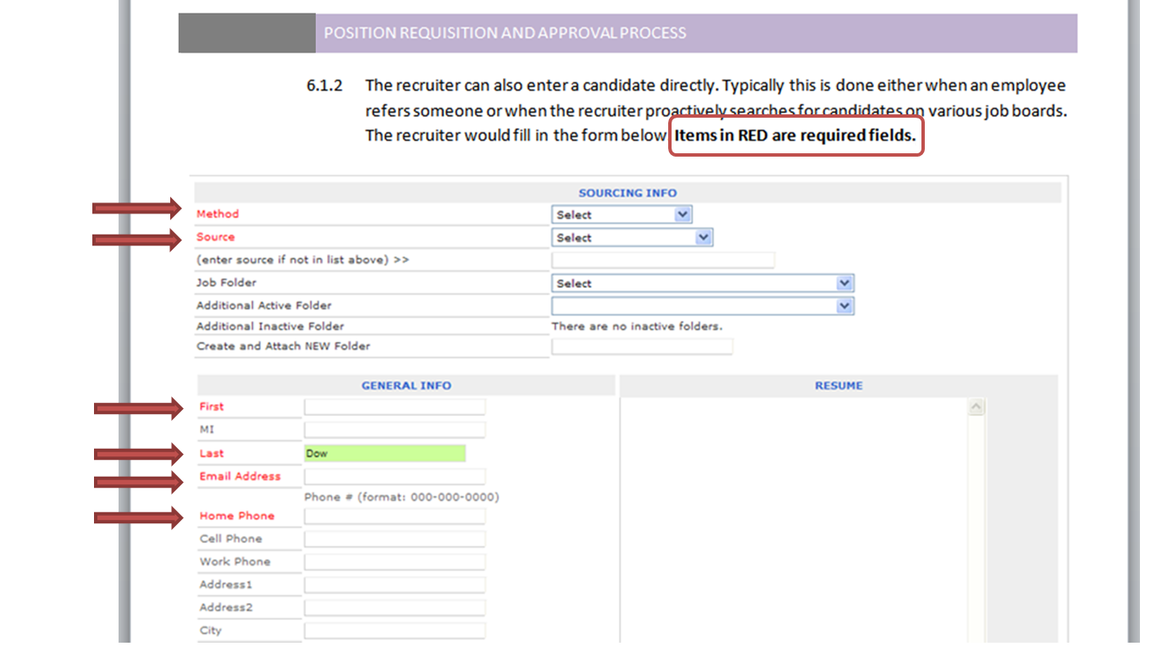

What is the Result?
Users may visibly perceive information and instruction when alternative distinguishing features are used such as:
- The use of Strong, larger, or italic font is used in combination or instead of color
- The use of symbols, such as asterisk (*) or pound (#), is used in combination or instead of color.
- The use of an underline or pattern is used in combination or instead of color.
Using any of these alternatives may be beneficial to users with colorblindness.

Users may not be able to visibly perceive information and instruction if they are color dependent. Users with colorblindness may not be able to obtain information from the document because alternatives to color are not used.

Color Contrast
High contrast helps users distinguish between text and the background on which the text appears. Tools can test for the proper contrast ratio of 4.5:1 provided between the text (foreground) and its background.

What to do
Analyze the color contrast between text and its background.

Tool(s) to use
Colour Contrast Analyser (CCA)

How to use
- Open the document in Adobe Reader.
- Open the Colour Contrast Analyser.
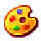
- Scan the page for text with color combinations other than black text with white backgrounds (and vice versa). Below is an example that can be used.

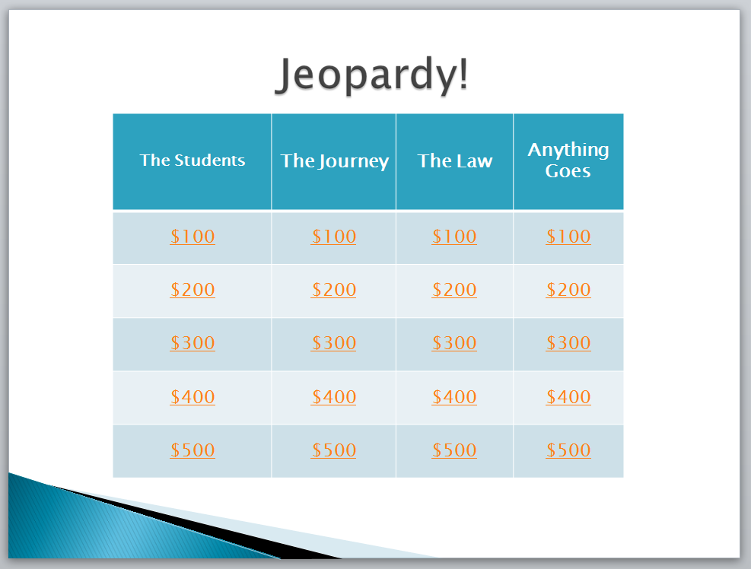
http://www.merlot.org/merlot/downloadFile.htm?fileName=Nanabek%2fIntroductory+Inclusion+jea.gm.pptx
- Using the CCA’s Foreground Colour Sampler, select the color of the text by placing the cross hair in the center of the letter.
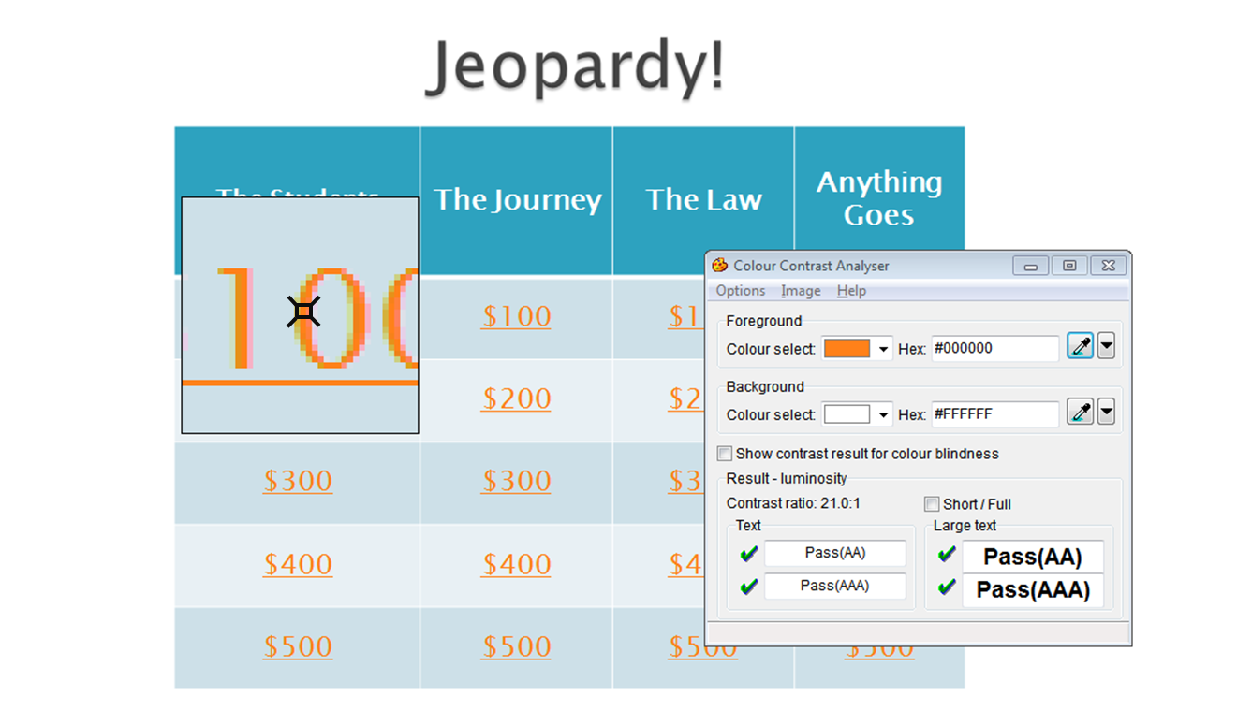
- To analyze the contrast, use the Background Colour Sampler and place the crosshair just outside of the letter previously selected.
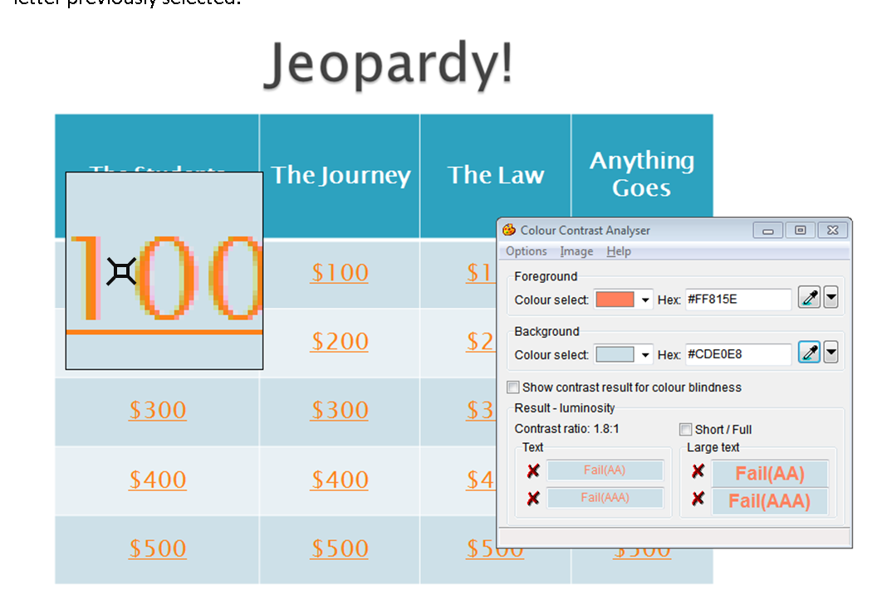
Note: Use the Colour Contrast Analyser. Do not assume that the contrast is accessible without using a color contrast analyzing tool. Sometimes, the contrast between text and background may appear like it should pass a color contrast test, but when tested, fails due to low contrast.
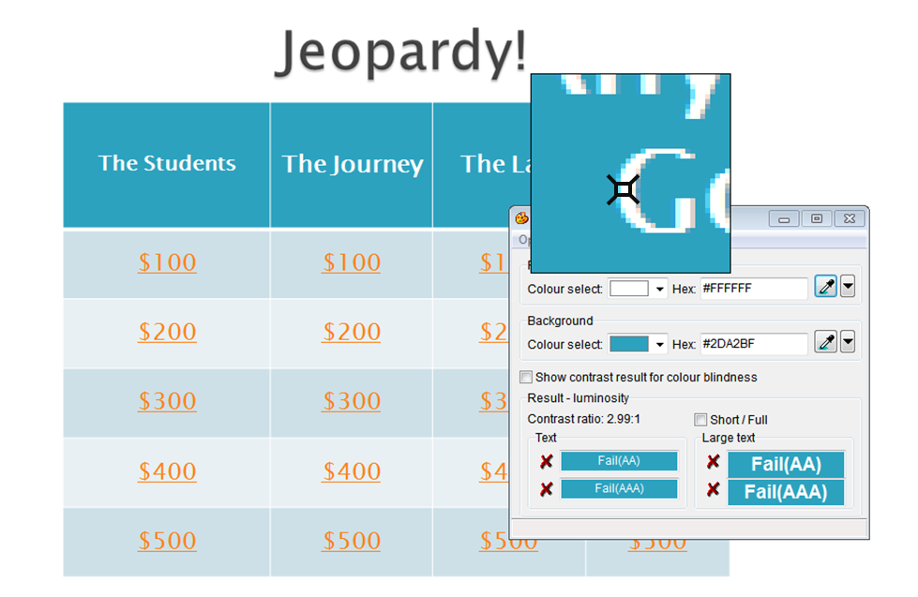
- Review the Results at the bottom of the CCA.

What is the Result?
If there is a green check mark next to the word Pass (AA), then the text and foreground color combination has a high enough contrast that is suitable for most people.
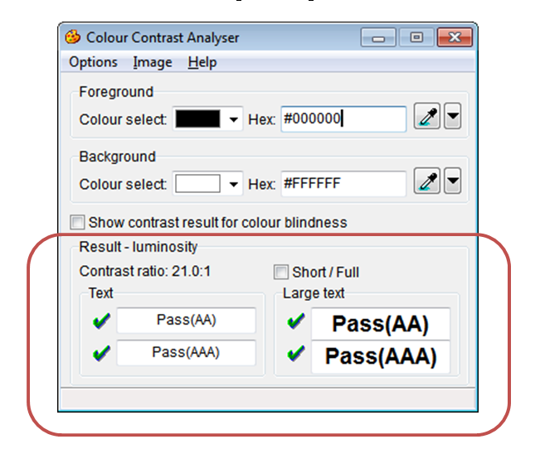
If there is a red x next to the word Fail (AA), then the text and foreground color combination does not have a high enough contrast and people with color blindness may not be able to read the text.
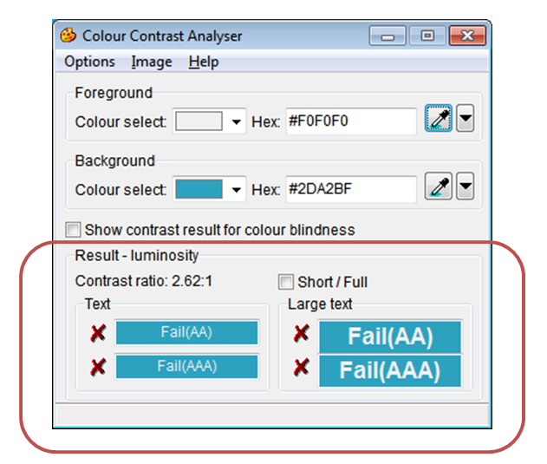

Language
The language used in the document is conveyed to users of assistive technology. This helps with the way the document is read.

What to do
Verify the language set for the PDF

Tool(s) to use
PDF Accessibility Checker (PAC)

How to use
- Save the PDF on the computer

- Open the PDF Accessibility Checker
- Select the Browse button and select the saved PDF

- Select the Start button

- Select the Logical Structure button

- In the Structure Elements: list on the left, select Document at the top.
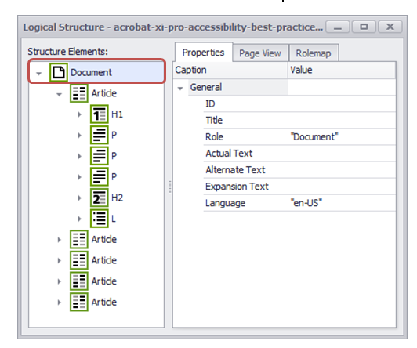

- On the Properties tab, verify that there is a language specified for the document.
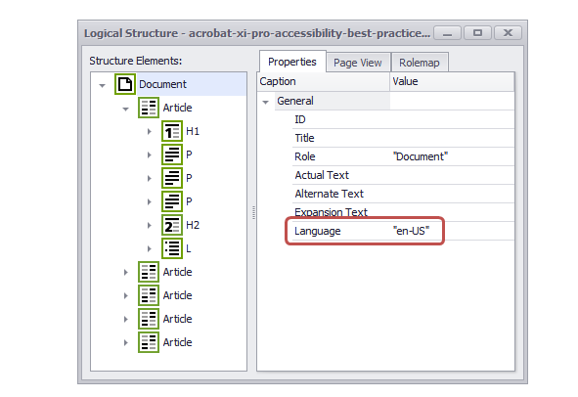
Note: If the document contains content in more than one language, go to that section in the Structure Elements: list and verify that that the language setting is correct.

What is the Result?
If the document’s or section’s language is appropriately declared, then the content may be conveyed through assistive technology in the intended language.
The document’s content may not be correctly conveyed to readers using assistive technology if there is no language declared for the document or content or if the language declared is incorrect.

Resources
Language Codes

Images
Meaningful images should be described for all users. As authors, consider what message the image is meant to provide. If it is meaningful, a brief description of the intended information should be provided.

What to do
Check the images in the document for alterative text or a description of the image in the surrounding text.

Tool(s) to use
PDF Accessibility Checker (PAC)

How to use
- Open the PDF Accessibility Checker
- Select the Browse button and select the saved PDF
- Select the Start button

- Select the Screenreader Preview button
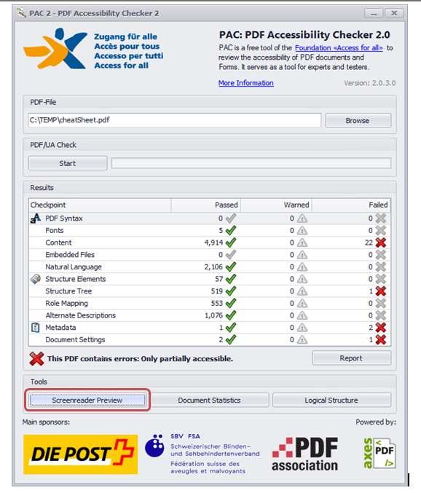
- Scroll down to where images are in the PDF. Look specifically for beige colored Figure and Alt sections
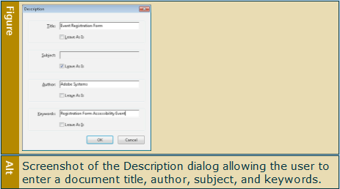

What is the Result?
If there is text inside the Alt area that describes the image in the document, then assistive technology users will be able to understand the meaning and purpose of the image.
The image has proper descriptions if:
  - The alternative text description is short and meaningful. The image may be described to assistive technology users.
  - Complex images, charts, and graphs are described in surrounding text for all users to read. Complex images may also be supplemented with a link to additional information.
  - Decorative images do not have alternative text descriptions. These images may be ignored by assistive technology which decreases the amount of non-important information the user of assistive technology will hear.
Note: The following images do not need to have alternative text descriptions: ✓
- decorative images
- unimportant images
- important images that are described in a paragraph above or below

The document does not have proper alternative text if:
  - The Alt area is blank for an important image without further explanation in surrounding paragraphs.
  - The Alt area does not have a short description of the image’s function, meaning or content.
  - The Alt Description area contains a web address (unless the image is of a web address).
  - Decorative images have alternative descriptions.

